Vision Education Scoping Report
March 2013
Contents
1. Executive Summary 5
1.1. Introduction 5
1.2. Overview of blind education 5
1.3. Types of media and information that needs to be accessed 5
1.4. Technologies used for vision access 6
1.5. Issues and solutions – textbooks 7
1.6. Issues and solutions – video 7
1.7. Issues and solutions – in-class resources 8
1.8. Issues and solutions – web access 8
1.9. Issues and solutions – homework and excursions 9
1.10. Issues and solutions – other 9
1.11. Conclusion 9
2. Introduction 11
2.1. Context of the study 11
2.2. How we went about the study 12
2.3. What the study sets out to achieve 12
2.4. What the study is not 13
2.5. Anonymity of information provided 13
2.6. About the authors 14
3. Overview of blind education in Australia 16
3.1. Number of students 16
3.2. Division of blindness and vision impairment 17
3.3. Approach state-by-state, territory-by-territory 17
4. Types of media and information that need to be accessed 19
4.1. Issues 19
4.2. Textbooks 19
4.3. Video materials 20
4.4. Web-based resources 20
4.5. In-class resources 20
4.6. Practical subjects 20
4.7. Homework 21
4.8. Excursions 21
5. Technologies used for vision access 22
5.1. Introduction 22
5.2. Mainstream or specialist technology? 22
5.3. Trends in access technology 23
5.4. Conclusions and implications 24
6. Issues and solutions 25
6.1. Textbooks 25
6.2. Video 29
6.3. In-class resources 34
6.4. Web access 38
6.5. Homework and excursions 43
6.6. Other 45
7. Conclusion 48
8. Recommendations for further action 50
8.1. Textbooks 50
8.2. Video 50
8.3. In-class resources 50
8.4. Web access 51
8.5. Homework and excursions 51
8.6. Information and other 51
Appendices 52
A. Technologies used for vision access 52
A.1. Mainstream technologies for people with vision impairments 52
A.2. Specialist technologies for people with vision impairments 57
A.3. Screen readers and DAISY 59
A.4. OverDrive 61
A.5. Supplier and pricing information 62
B. Alternative print production in schools – Braille, audio and tactile materials 63
B.1. Braille software 63
B.2. Braille production – methods for small bodies of text or personal use. 65
B.3. Braille printing – methods used in educational production centres 66
B.4. Large print 68
B.6. Audio format 74
B.7. Embossing for tactile images 76
C. Access to the Internet and websites 80
International standards 80
Government initiatives 80
Australian initiatives 80
D. The overseas experience 82
D.1. Introduction 82
D.2. Audio description services 82
D.3. Major initiative – Described and Captioned Media Program (USA) 84
D.4. Major initiative – National Schools Film Week (UK) 84
Glossary 86
Acknowledgements 90

Executive Summary

Introduction
This study of vision education services evolved from the extensive work that Media Access Australia (MAA) has undertaken in deaf education and access to technology and media. MAA has also drawn on its other work in media and information access to explore the wide range of issues faced by blind and vision impaired school students. The research is not a census, but a detailed overview looking at systems, processes and technology currently being used. The study looked at all of Australia and reviewed WA and NSW in more depth to glean any insights into two very different environments and approaches.
The study is a comprehensive review of the services with public, Catholic and independent sectors all being examined, as well as identifying the range of information and media needs facing blind and vision impaired students. The technologies used have been reviewed and MAA has commented on accessibility and other information around this use, including overseas experience. There is extensive reporting of consultation with the providers and support staff who generously gave their forthright opinions and expertise in assisting the review. To ensure that the report can provide practical, ‘tell it like it is’ information on the state of the services, there is a degree of anonymity in the reporting to de-identify individuals.
The report is not intended to be an accurate census of every experience or to cover every single piece of technology used in schools across Australia. However, it does provide a very strong overview and identifies a number of areas where existing strengths can be shared and built on, and offers solutions to some pressing problems.
In compiling this report, five MAA experts undertook the major research work and spoke to over 50 passionate, dedicated people working in the sector across Australia and overseas.

Overview of blind education
It is difficult to accurately determine the number of children in Australia with vision impairment, mainly due to differences in definitions from state to state, territory by territory. However, a reasonable estimate is up to 4,000 school-age students. Similarly, whilst there is no exact split between blindness and vision impairment, the vast majority of people are vision impaired, in the range of 85-90%. One consequence of this is that although Braille is an effective and widely-used tool, the vast majority of students do not use it.
There are a variety of approaches to blind education across Australia. The main difference is the use of a centralised approach (such as WA, SA, Victoria, NT) or a devolved approach whereby the three education sectors look after their own needs (such as NSW, and Queensland from 2014). The size of service (NSW public sector is 800 students alone) and geographic issues are major factors in the delivery of the service. These issues impact the approaches and solutions across the country and are discussed in more detail in those sections.

Types of media and information that needs to be accessed
Blind and vision impaired students need to access the same media (e.g. DVD, television, online video) and information (web pages, textbooks, resources, in-class demonstrations) as the rest of their peers. The key questions around accessibility are related to the need for modification of the media or information and how that is achieved via modifying the information itself or providing a device/technology that makes the information accessible. Lead times for the production or acquisition of the resources is key, along with the degree of choice. Is the resource a set text or fixed piece of information, or are there options from which an accessible resource could be chosen?
Textbooks are still a major education resource and the number used by a student increases as they move from primary to secondary school. For blind and vision impaired students, the fundamental issue is providing the book in some kind of alternate format.
Video materials are growing in importance, are compulsory resources in some cases, and can cover DVDs, online video, television programs and student-generated video. The primary form of access to video is audio description, but this is very underdeveloped in Australia, mainly occurring in cinema and on DVD with the possibility of a limited television service being introduced following a 2012 trial on the ABC.
Web-based resources are used widely and whilst there are international accessibility standards (WCAG 2.0), most websites do not meet these requirements. Assistive technology can help overcome this; however, there is still some content that is inherently not accessible (such as images, visual diagrams and some PDF files).
A major issue around in-class resources is lead times. With alternate format production time being measured in weeks rather than days or hours, it means that some resources or information found by a teacher at short notice (even the previous week) may not be able to be made accessible in time.
Practical subjects such as science, technical subjects and art present major problems because of their visual nature and some inherent safety issues (hot stoves, sharp edges, dangerous chemicals, etc.).
Homework presents issues around the accessibility of online resources that need to be accessed to research or complete homework exercises, and a practical issue around the portability of assistive technology so that it can be used at home as well as in the classroom.
Finally, excursions off-campus reduce the ability of the school to control the environment and make some elements of the experience accessible. The issue of portability of assistive technology also affects this area.

Technologies used for vision access
The range of technologies and a detailed explanation of how accessible they are is featured in Appendix A. The type of technology used in schools is similar to the technologies used by blind and vision impaired people at all stages of their lives. The main issue around technologies is whether they are mainstream or specialist in nature.
Mainstream technology usually has access features that allow it to be used by blind and vision impaired people, whereas specialist technology tends to be developed to meet a particular need of a blind or vision impaired person. Examples of mainstream technologies include accessibility features of computers, iPhones/iPads and e-readers. Specialist technologies include electronic magnifiers, Braille devices and screen readers.
Mainstream technologies tend to be widely available, evolving, lower cost and multi-functional. However, they may not necessarily fully meet an access need and their access features are not widely known. Specialist technologies are usually highly suited to their specific purpose and have good sales and technical support. However, they tend to be more costly, have a limited range of suppliers and require specialist training and support.
Important technology trends are: the reducing costs of mainstream technology with access features contrasted with the higher cost of specialist technology; the emergence of free access products online, such as the NVDA screen reader; the provision of specialisation and customisation through applications; and the growing use of technology in schools making the accessibility features of technology more important.

Issues and solutions – textbooks
Production of special format (Braille and large print) text books is very time consuming and can take hundreds of hours. The need for permission and access to components of the book from a publisher adds to this problem. This results in long lead times for production of books.
The high cost of producing alternate formats means that in some instances other alternatives are investigated first, such as electronic versions of a book (if they are available). There are some instances of the same book being independently produced in large format in different places. This could be overcome through sharing of information and resources. Copyright issues and sharing of resources were identified as being the two main priorities for alternate print production.
The use of alternative media is contentious. Some see it as a way of reducing costs and early trials, such as the NSW trial of OverDrive (an electronic borrowing system), have shown some benefits. Others maintain that the best product is a re-creation of a book as close to its original format as possible, particularly as audio books require a good memory and organisational skills from the user.
The alternate print industry is well-established and produces good quality product, albeit at a high per unit cost and with generally long lead times. Electronic and audio versions may offer a better solution, but these need to be investigated in a systemic way, looking at simpler books first (such as novels).

Issues and solutions – video
Video is the least developed in terms of access for any media or information in schools. This is becoming more problematic as the use of audiovisual materials is increasing in schools, including being a core part of the curriculum. The accessibility of video is directly related to the low availability of audio description (AD) in mainstream media in Australia. Whilst Australia has the highest levels of DVD AD in the world, there is no permanent television AD service and online media does not offer AD.
The only comprehensive AD program for education materials in the world is provided by the Described and Captioned Media Program (DCMP) in the USA. The use of captioning in schools (which MAA has extensive experience in) is a good illustration of how an increase in services and information can be rolled out. The lack of general information about AD and its use among specialist teachers is a major priority to start overcoming the issue. Similarly, this could help inform schools and encourage them to choose audiovisual material that is already audio described as an option. At the moment there is no real awareness of this. Finally, the process of targeting distributors of specialist education titles and educating them about the need for AD should commence. This approach has been effective in increasing the number of captioned titles from these distributors.

Issues and solutions – in-class resources
The most common issue is the provision of alternate versions of graphs, diagrams and illustrations used as in-class resources. The long lead times from the specialist print production facilities do not support this need very well.
Some services use a variety of low-tech and specialist technology to overcome this. Picture in a Flash (which creates a raised surface through heat), various tactile materials and even spaghetti and jelly crystals are used to explain concepts. Some schools have mini Braille production centres that allow onsite production of materials. For vision impaired students, they rely more on technology such as magnifiers, but there are concentration and social issues around the use of these (being seen to be ‘different’).
Practical subjects are the trickiest and are compulsory subjects up to early high school. Whilst many blind students are relegated to passive observers, new equipment such as the data loggers provided by Vernier LabQuest provide accessible science equipment. Similarly, home science classes could use products sold to assist blind people in cooking at home that are available through organisations such as Vision Australia.
The priorities are around having a more consistent approach to the provision of in-class resources and sharing knowledge and ideas from different schools. Similarly, encouraging students to take a more active part in science classes could be assisted by an evaluation of new accessible science equipment.

Issues and solutions – web access
This is the most significant area for blind and vision impaired students as more learning is conducted online or using online resources, particularly websites. Technology is vital in providing access. A fundamental issue is that even with accessible technology, the websites themselves are often not accessible as they have not been formatted to meet international accessibility standards and to work with the technology that is available.
Schools are concerned about selecting the right technology to suit the needs of individual students, and are calling for independent information about the accessibility of technology, particularly mainstream technology. The use of Apple products has increased significantly, but there is still a need for information about the best use of these products and the applications that drive them.
Reliability of technology can also be an issue, particularly when specialist applications (such as JAWS) are added to system-wide software and laptops and functionality of the specialist software is sometimes reduced. This links with the very patchy support and maintenance by IT departments. This is often due to a lack of knowledge of specialist software or even how to enable access features of mainstream systems. Education of IT specialists working in schools was seen as a way of overcoming this. Similarly, there are some specialist teachers who have detailed, practical knowledge of particular systems and good troubleshooting skills, but this is not captured and shared for the benefit of all.
The high relative cost of specialist equipment was raised by many, but many sectors are reluctant to explore other options in the absence of good independent information about mainstream alternatives and how they can be used in schools. Furthermore, whilst free specialist software may be beneficial, there needs to be independent information about this.

Issues and solutions – homework and excursions
There is often a disconnect between the school and home environment and supporting the student. The lack of accessible websites makes research for homework more difficult and this is compounded by a lack of accessible equipment available at home. This could be overcome through better parent education around access features of home computers, the use of AD in the home and the use of free screen reader software.
Excursions are similarly difficult to access as they are away from the school campus. There are some developments in performing arts venues and museums, and teachers need to be made more aware of these facilities so that they plan ahead of a school visit.

Issues and solutions – other
Education is organised at a state/territory level and then within the public/Catholic/independent sectors within those. This means that there is little formal communication and collaboration between locations and sectors. Differing population sizes also lead to significant differences in capacity, particularly around alternate print production and knowledge of technology and systems.
The sharing and communication of knowledge across these boundaries is essential, especially capturing the specialist knowledge of individuals. There is a strong willingness to collaborate and share; what is lacking is a mechanism to achieve that.
Time pressures suggest that simple, short bursts of information would be more effective and more detailed knowledge could be provided in formats that can be accessed anytime and updated easily (such as audio or video).

Conclusion
Technology use is widespread and growing, but the pace of change and fragmented environment that services operate in means that they cannot always harness the benefits of technology.
The barriers to alternate print production are centred on copyright, duplication of effort and the lack of sharing resources. The use of alternatives is growing but more careful evaluation is needed before these can claim to be viable replacements for all traditional print production. The real answer probably lies in using these electronic and audio alternatives to complement the large print and Braille books.
Access to video is the least developed area and there is a very basic need to provide information about how it works and what resources exist.
Collecting, documenting and sharing information on how to provide better accessible in-class resources will progress this area. Science experiments are a more complex problem, but new equipment and solutions coming onto the market offer some hope.
The primary issue is the need for independent, credible information about access technology, mainstream alternatives and for that to be communicated clearly and simply. There is some existing knowledge and this needs to be captured and shared. IT professionals working in schools need to be included in this process to ensure that they can support the specialist needs of blind and vision impaired students within the context of delivering school-wide IT support.
The accessibility gap between home and school also needs to be addressed.
There is much enthusiasm and support for solving these issues, with the key task being to prioritise and focus on what is practically achievable. Recommendations for this are covered in Section 8.

Introduction

Context of the study
Media Access Australia (MAA) is a well-established not-for-profit organisation that focuses on practical, real-world access to media and information for people with disabilities using mainstream technology solutions. It started out in 1981 as the Australian Caption Centre and ran a highly successful access business which was divested to Red Bee Media in 2006 to provide the core funding for MAA to further develop access to media without the conflicts of also being a major service provider in the area.
MAA engages with all forms of electronic media, including: television, DVD, cinema, online video and audio, access to the Internet and online information. MAA operates as a catalyst for change. This means that although the market may eventually provide acceptable levels of access to particular media, the likely timeframes may be so long as to be worthless. MAA looks at opportunities to speed this process up and uses its knowledge of technology and industry to identify areas that can help build momentum for change, generally with the cooperation of industry, consumers and government.
A key factor in this approach, and an important basis for this study, is that MAA sets out to understand the way in which a particular industry and any associated technologies work in a practical sense. MAA has a reputation for good quality research and analysis and explaining its outcomes in practical, real-world terms.
Importantly, MAA does not claim or seek to represent consumers of media. That role is undertaken by other organisations which MAA has strong working relationships with.
Among its range of programs that MAA has created and developed is a very successful, wide-ranging education program dealing with hearing impairment access. This is very much centred on the use of technology and its interaction with captions. A key component of this has been the Captioning Grant, provided by the Department of Families, Housing, Community Services and Indigenous Affairs (FaHCSIA). This grant has evolved over many years, moving from its initial provision of open captions on VHS videos to its current form whereby education and community DVDs and online video are captioned. This reflects MAA’s fluid approach to the changes in technology and realigning its focus onto new areas as access is achieved in particular media.
With MAA’s success in deaf education access and its extensive work with blind and vision impaired people in access to other media, there has been strong interest in MAA undertaking some kind of role in education access for vision impaired students. In the context of this study, MAA undertook some initial research and held brief discussions with some key stakeholders. The general conclusion was that the issues for vision impaired students were not solely about providing audio description on DVDs and online video (in other words a replication of the deaf education program). The needs of vision impaired students in access to information are far more complex and there are different solutions presented to meet those needs.
In line with MAA’s real-world approach, we agreed that the best approach was to undertake a scoping study identifying the media and information needs of blind and vision impaired students and review the current systems and technologies used to deal with those needs. FaHCSIA has supported this approach from MAA and agreed that a portion of the Captioning Grant would be allocated to a scoping project.

How we went about the study
Our preliminary research undertaken in late 2011/early 2012 informed us that there wasn’t a need to undertake highly-detailed, in-depth research for each state and territory. What we were looking for was information on general approaches, information on technology used and issues that people saw associated with those approaches. Our interest was in the recurring issues and approaches rather than isolated, one-off solutions that were peculiar to very specific circumstances. We also wanted to make sure that we focused on technology, as it is an area of MAA expertise and one that has not been widely addressed in a systematic way before.
We also wanted to ensure that we picked up issues around the sizes and geographic spread of blind and vision impaired student populations. For that reason (and the fact that MAA has offices in both Sydney and Perth), we undertook very detailed and widespread research in both WA and NSW. For other states and territories we spoke to the people running services and particular individuals who had some specific knowledge about an issue covered in the report. This approach has not provided any bias or skewing towards WA or NSW issues and solutions. In fact, we found that the issues were pretty common across services and the in-depth approach helped to nuance some of the factors that might impact on solutions to issues raised. What is particularly useful is that WA has a centralised service (covering all sectors of education) whereas NSW has different vision impaired services covering public, Catholic and independent school sectors.
For information on the technology itself, we spoke to production facilities in various locations, interviewed suppliers of specialist equipment and reviewed product information. We also drew heavily on MAA’s extensive resources covering web accessibility and audio description.
A list of people who we spoke to is included in this report.

What the study sets out to achieve
The study covers a range of issues:
- A basic understanding of the structure and magnitude of blind/vision impairment services across Australia. This includes looking at numbers of students, how the services operate (are they integrated or separated for public, Catholic and independent sectors?), basic services that are provided and particular factors that might impact on their service delivery (e.g. geography, funding).
- The media and information that needs to be accessed by students. This includes textbooks, video material, web articles, in-class resources, science experiments, homework and excursions. We look at the current levels of access to this and where there are gaps.
- Technology options available generally to blind and vision impaired people. This part of the review identifies broadly used technologies and equipment that are available to people in Australia. We also provide some data and information on the level of accessibility that these options provide.
- Commonly used technologies and solutions used by schools and education services. This section identifies solutions taken up by education services and includes some detailed explanation of how those processes currently work (e.g. large print book production). In some cases these solutions are universal, sometimes specific to a location or unit.
- Specific issues and areas of concern identified by education services and providers. These may be around the technology itself or information/communication issues that need to be solved.
- Brief reference to overseas experience and their use of technology, but this is not exhaustive and intended to illustrate a couple of programs and developments that have some relevance to Australia.
- Recommendations from MAA of how some of the identified issues can be resolved. This ranges from simple solutions (such as identifying which of the prescribed movies for high school study are audio described) to more complex projects that explore new ways of approaching an issue. Each recommendation is practical in nature and has detail of what would be required.
- An acknowledgement of the range of experts and sources that we consulted with and a glossary of important terms and concepts.

What the study is not
An important dimension of this study is to be clear about what it is covering and what it is not covering or intended to be, namely:
- Not a census or statistical review of the numbers of blind and vision impaired students and their geographical location. As the study shows this is a difficult figure to fully determine, but the study looks more at the magnitude of the needs and the geographic spread.
- It is not a critique of the adequacy or otherwise of the provision of services to blind and vision impaired students across Australia. The delivery of such services is complex and varies significantly from location to location. What the study focuses on is the specific information and media needs and how those are dealt with using technology. MAA acknowledges the passion and dedication of the people working in the sector and their commitment to making the services work as best as possible for their students.
- It does not cover every single item of technology or solution used for every need of a blind or vision impaired student. There are some highly creative individuals who have created unique approaches to very specific problems, but what we have focussed on is the main solutions that have widespread use (or the potential for widespread use).
- It is not favouring particular suppliers or technologies over others, except where we see a significant advantage of the use of a particular product in a situation.
- Not an overarching, “this is the solution to everyone’s needs” set of recommendations. MAA takes the approach of incremental change and working through practical trials and small-scale projects to ensure that solutions work in real-world settings.

Anonymity of information provided
During this study we talked to many professionals from the vision education sector, teachers, print production specialists and others about their work and experiences. In many cases they were willing to discuss issues freely on the understanding that they were not identified with particular opinions or viewpoints. This was often because they were satisfied with the overall service but had a particular gripe or issue that wasn’t being resolved. They were also not necessarily the designated spokespeople for organisations and Media Access Australia felt that attributing statements to particular individuals would require organisation clearance and that would be both cumbersome and in some cases likely to lead to a “no comment” response. In the report there are some direct references to education authorities or agencies. These are generally to illustrate a particular point that was made and where the comment was not controversial.
That said, the majority of issues raised in this report are about changes to process, or sharing of information or looking at areas that are not well developed. The sector is filled with dedicated professionals who are working very hard to deliver the best possible service for blind and vision impaired students. The overarching response we received from the people that we talked to was a positive embracing of the study as they saw opportunities to move forward, develop new services and have some assistance in overcoming frustrating barriers.
In putting together the report, we have focused on common issues that were raised by a number of people, rather than one-off items that do not reflect a systemic issue.

About the authors
This study drew on the expertise of a number of Media Access Australia staff:
Dr Scott Hollier, Manager, Major Projects
Scott joined Media Access Australia in 2008 and has a focus on computer and Internet related technologies.
With a PhD entitled The Disability Divide: an examination into the needs of computing and Internet-related technologies on people who are blind or vision impaired, Scott has a wealth of experience in computer science and information technology.
Scott represents Media Access Australia on the Advisory Committee of the World Wide Web Consortium (W3C), the organisation primarily responsible for developing web standards that ensure the long-term growth of the web. Amongst the many projects he is working on Scott takes time out once a month to write a column with up-to-date news and information about the W3C.
Scott is legally blind and as such understands the importance of access at a personal level.

Anne McGrath, Education Manager
Anne works part time as the Education Manager at Media Access Australia.
Anne has worked as a primary school teacher in mainstream schools and as an Education Project Officer with the NSW Department of Health, where she worked on the award winning, internationally acclaimed Triple A peer education program. She has also worked for the NSW Department of Education and Training as an Itinerant Support Teacher Hearing (ISTH) and as a Teacher/Consultant in Hearing Impairment for RIDBC (Royal Institute for Deaf and Blind Children) School Support Services.
Anne also currently works part time with the Catholic Education Office, Sydney, as an Itinerant Teacher Hearing with the Sensory Impairment Program, working directly with students who are deaf and those who have hearing impairment in Catholic mainstream schools.
Anne has personal experience of hearing impairment, growing up with a deaf mother and being hearing impaired herself. Anne uses hearing instruments and assistive listening devices in her daily life.

Karina Scott, Education Assistant
Karina joined Media Access Australia in mid-2010 as the Education Assistant.

Karina has just completed a Bachelor of Education/Bachelor of Arts at the University of Sydney, and graduated as a high school English and Drama teacher at the end of 2012.
Karina has been a volunteer mentor with Australian Indigenous Mentoring Experience (AIME) since 2008, and enjoys the dynamic nature of working with teenagers. She has also previously volunteered with a variety of students who have special needs, in both a respite environment and educational context.

Alex Varley
Alex Varley has been the Chief Executive of Media Access Australia since its inception in 2006. Alex was previously the General Manager of MAA’s predecessor the Australian Caption Centre.
With that extensive experience in access issues, coupled with a Bachelor of Business in marketing from NSWIT and post-graduate qualifications in town planning from Macquarie University, Alex is well equipped to lead a practically focused organisation that looks for real-world solutions.
Alex was the inaugural chair of the communications advocacy organisation Australian Communications Consumer Action Network Limited (ACCAN) and is a director of Australian Social Innovation Exchange Pty Ltd (ASIX).
Before joining the Australian Caption Centre/Media Access Australia, Alex held senior positions at the Sydney Theatre Company, Australian National Maritime Museum and BP Australia.

Allayne Woodford
Allayne is the project manager focused on access to DVD, cinema and the arts. She has been with Media Access Australia and the Australian Caption Centre since 1999. Allayne originally joined the organisation as the Executive Assistant to the CEO, but her passion for access and interest in project management led her into her current role.
Before joining Media Access Australia, Allayne worked in a variety of roles within the NSW Ministry of the Arts, now known as Arts NSW.

Overview of blind education in Australia

Number of students
There is no official figure for the number of Australian children with a vision impairment. Estimates of the number of Australian children with vision impairment are:
- Estimated at 3,000 – from Christine Morris and Umesh Sharma (2011). Facilitating the Inclusion of Children with Vision Impairment: Perspectives of Itinerant Support Teachers. Australasian Journal of Special Education, 35, pp 191-203
- More than 1 in 2,500 – from Royal Institute for Deaf and Blind Children (RIDBC)nsw
- There are more than 411,000 cases of long-term eye disorder among children in Australia, mostly being long and short-sightedness. From the Australian Institute of Health and Welfare, Canberra (2004-05), Eye Health Among Young Australians report of 2008.
- About one in six 10-14-year-olds wear glasses or contact lenses to correct sight. From the Australian Institute of Health and Welfare, Canberra (2004-05), Eye Health Among Young Australians report of 2008.
Vision impairment is often associated with other disabilities but the vast majority of vision impaired students attend mainstream schools.
RIDBC estimates that 4 out of every 10,000 children born in Australia will be diagnosed with severe vision impairment or blindness by their first birthday but there are no accurate statistics to verify this figure. The number of blind or vision impaired children enrolled in RIDBC programs has doubled in the last seven years.
RIDBC has started the Australian Childhood Vision Impairment Register in partnership with low vision service providers, education providers and eye health professionals across Australia. The aim of the register is to collect data to build an accurate picture of Australian children with vision impairment. The data is used by groups who provide services to children with vision impairment and also by researchers working in the field of childhood eye and vision disorders.
As of February 2013 there were 815 registrations with a gender division of 58 per cent boys and 42 per cent girls. A data run of the school-aged children between 6-18 years showed the following percentages around vision itinerant teacher support:
- 27% answered yes, they received vision itinerant teacher support
- 42% answered no, they didn’t receive vision itinerant teacher support
- 18% answered they didn’t know if they did or didn’t
- 13% did not answer
It should be noted that a lot of the children on the register have multiple disabilities so vision itinerant support may not be suitable for their needs.
The register is expected to peak between 3,000 and 4,000, based on evidence from countries of similar socio-economic status projected over the next decade or so. The higher estimate of 4,000 is due firstly to the increase in the number of premature babies being born (from younger mothers and IVF mothers) and the increase in survival rate of these babies. One of the predominant problems of premature babies is sight issues.
A range of data is collected on the register including but not limited to:
- Eye conditions – currently there are over 60 different diagnoses with the five most common being cortical vision impairment (14 per cent); retinal dystrophy (12 per cent), oculocutaneous albinism (9 per cent), optic nerve hypoplasia (7 per cent), optic atrophy (2 per cent) and others (56 per cent).
- Devices used to assist with vision – 26 per cent of children reported this. Devices include low vision aids, enlarge text, enhanced contrast and screen readers.
- Use of large print – 30 per cent of the currently registered children use large print.
- Use of Braille – currently 83 of the registered children (9 per cent) use Braille.
The register is consent-based which will mean not everyone will register. Similar registers in the UK and Scandinavia are considered compulsory. For the UK, government subsidies are only provided if people are on its register, and in Scandinavian countries all children are registered automatically as soon as they are diagnosed. Australian privacy laws work against this happening here.

Division of blindness and vision impairment
Similar to the message in Item 3.1 there is no exact ratio of Australian students with vision impairments to students who are blind. What we do know through this scoping exercise and anecdotally is that there is a much higher number of students with vision impairment (low vision, short-sightedness) compared to students who are blind. This detail lends itself to the notion that Braille is not a mainstream solution, akin to Auslan not being a mainstream solution for Deaf and hearing impaired people, as only a small proportion of this group will have learned this language.
What we do know:
- Almost 575,000 Australians over 40 have vision impairment (more severe than needing glasses), representing 5.8 per cent of the population in that age group. Of these people around 66,500 are blind. (Clear Focus: The Economic Impact of Vision Loss in Australia by Access Economics, 2009.)
- 285 million people worldwide are vision impaired, 39 million people are blind and 246 million people have low vision. (World Health Organisation.)
- Almost two million people in the UK are living with sight loss. (Access Economics, 2009)
- An estimated 218,000 people are legally blind in the UK. (Access Economics, 2009)
- There are an estimated 25,000 blind and partially sighted children in Britain, or 2 in 1,000 children. (Morris and Smith, 2008.)

Approach state-by-state, territory-by-territory
It is very clear that there is a variety of approaches across the states and territories. This is driven by a range of factors, including: the numbers of students that need to be supported, geographic size and population spread, cultural diversity and whether a single system deals with all school sectors or if it is separate to each sector.
With these factors in mind, it is not surprising that whole-of-state support compared to a division between education streams (government and non-government) differs, but not necessarily for the obvious reasons of geography and student numbers. For example, Victoria and New South Wales, two of the larger states, differ in their approaches. New South Wales divides its services between government schools (supporting more than 800 students alone) and the independent and Catholic sectors. Victoria, state-wide, supports more than 500 students but all students are assessed through the Department of Education’s assessment centre and access services and support are provided through the department as well. The public sector Education Queensland covers state, independent and Catholic schools, but this will be devolved from 2014.
The set-up of the two territories is driven by the fact that they both serve small numbers of students. The Northern Territory through its Department of Education supports students across all sectors, contrasting with the ACT approach which is separated. However the Catholic and independent sectors can pay for services through the public sector.
Students in all states and territories are supported in class by visiting vision education teachers (who have a range of titles). The ratios of teachers to students vary across the country. In the NSW public system the ratio is 27:160 whereas in WA the ratio is 29:410. WA has a larger geographic area divided into metro, regional and remote. The ACT has roughly 1:12 and the Northern Territory has 1:17, with serious issues around remotely located students.
Due to the remoteness of some locations, such as in the Northern Territory, visiting teachers visit less frequently but stay for a week at a time and cover more issues in one visit.
The delivery of advice, student assessment of needs and recommendations for technology ranges from for-profit specialist suppliers to independent assessment. The advice may depend on the availability of services to in different geographic areas, but this may be detrimental to the students’ needs and also the budgetary restraints of the service (for example specialist suppliers are likely to be narrower in their recommendations of products). Where mainstream technology has been adopted, such as iPads, issues around teacher knowledge can be limited. This then offsets some of the benefits of shifting from the better supported specialist products to cheaper off-the-shelf products.
Other services also vary. For example advice about mobility can be sourced from outside organisations like a guide dog association or from within a department of education.
The objectives around empowering mainstream teachers and the schools themselves can vary. For example, WA operates more as an advisory service and aims to build the capacity of the school (i.e. modified assessment approach). The NSW public system operates with a higher reliance on its head office. It provides an alternative print facility from 11 satellite service officers located in regional locations.
These factors permeate the report as we discuss different issues and identify solutions. However, the overarching message is that despite the diversity of services nationwide there is a strong common thread that better servicing the needs of the student is paramount.

Types of media and information that need to be accessed

Issues
School students utilise a wide range of media and information as part of their studies to be reviewed directly in class or outside of school (for homework or school excursions). This range of media and information that includes: textbooks, video material, web articles, in-class resources, science experiments, homework and excursions. This list forms the basis for which we will analyse the levels of accessibility and options available to blind and vision impaired students.
In dealing with media and information there are several factors which impact on the ability of the student to access the content and these have important implications for how access can be provided. Important factors include:
- Does the resource require modification to access the content or is the access provided through some kind of external device with no change required for the content itself? For example, a textbook may need to be recreated in a large print format to be read by a vision impaired student, whereas an Internet page may be magnified via a screen magnifier built into the computer but accessing the standard website page.
- What are the lead times for the resources? For example, set textbooks are determined before a school year commences (often later in the previous year) and thus there is some lead time to produce alternate versions, whereas a student undertaking her own research for a homework assignment could be attempting to access any online material.
- Is there an element of choice in resources being used? For example, a basic maths text for primary school years may be fixed and used by all students, whereas a DVD for high school study could be selected from a range of options, some of which may be accessible.
- Where is the resource going to be used? For example, a Braille version of a book may be suitable for use in class (Braille books are many times longer and bulky compared to a standard print version) but cannot easily be transported home.
- How ‘visual’ is the resource? A text document can be rendered into accessible forms with reasonable ease, whereas a complex diagram may require breaking down into different components before it is able to be made accessible.
- Is there any basic data on what portions of materials are used in a classroom and how this changes from primary to high school?

Textbooks
Textbooks still form a basic part of student resources and can also include set texts for English language, such as novels. Many of these are sourced from specialist suppliers and are used across school systems and state boundaries. The selection of a specified textbook assists with curriculum goals of teaching the same material and to uniform standards.
As a student progresses from primary school to high school, the number and range of textbooks used by the student increases and the books become more specialist and topic-specific. Similarly, the number of other books that may be used by a student (sometimes through their own research) increases as students reach high school and undertake more in-depth study of a topic. This need for outside books (from a library) has been replaced to some extent by the use of online resources accessed from the Internet.
For a blind student, the primary issue with a text or other book is that it is a totally visual medium and is therefore inaccessible unless provided in an alternate format. These formats include translation into Braille and the use of audio formats. For vision impaired students large print formats are also provided (the production of large print is covered extensively in section 5.4).

Video materials
Audiovisual materials now form part of student resources and these are typically provided as DVDs or online/downloadable video. The range of video materials viewed include: entertainment (popular movies and television shows), mainstream documentaries and specialist subject education material. Some high school subjects include the possibility of a student creating their own video material.
The most obvious form of access for video material is audio description (see section 9.2). However, in Australia this is restricted to entertainment DVDs. There was a trial of a limited audio description service on ABC Television in 2012 and there is a possibility of a more permanent service being provided on the ABC, but this will be restricted to a few hours per week and mainly cover entertainment programs.

Web-based resources
The Internet is widely used in schools for researching subjects and for student assignments. Whilst there are international accessibility standards for websites (Web Content Accessibility Guidelines 2.0) most websites do not conform to these standards and even those that have some accessibility, have other features of their website that restrict access. Blind and vision impaired students face two major problems with accessing websites. First, it may be impossible to navigate around them, even with assistive technology, due to the fundamental design and construction of the website. Second, some of the content may not be provided in forms that are accessible or easily made accessible (such as visual diagrams and images, PDF files used for downloads, etc).

In-class resources
Not all resources used in schools are pre-determined or provided with long lead times. A teacher may use a resource that he found on the Internet or in an article that illustrates the concept that they are trying to teach. Such handouts could potentially be made accessible, but the systems for doing so, may take time and not be practical for a spontaneous use of newly found resources. Similarly, a teacher may write a series of notes on an interactive whiteboard and then print those out for the students to take home. Lead times for most large print or Braille facilities is measured in weeks rather than days or hours.

Practical subjects
There are some elements of the school curriculum that are compulsory and structured around practical exercises, or include practical components. For example, technical science subjects such as woodwork and metalwork have practical, hands-on components. Home science includes cooking food. Science subjects include the need to undertake experiments, build machines or dissect animals in biology. Art involves creating visual or tactile works. The main issues around these subjects are potential danger from chemicals, electricity, sharp objects (scalpels, knives, cutting tools used in woodwork) and heat sources (stoves, Bunsen burners, etc).
Science experiments also have the need to record results and observe changes, which are all difficult visual exercises. Cooking and preparing food is an important life skill as well as part of the curriculum around health and nutrition. Art is particularly useful in teaching manual dexterity, sensory awareness and spatial orientation, which are very useful general skills for blind or vision impaired people.

Homework
Homework assignments can be problematic if the student is expected to use the Internet and other resources for their own research, given that some of the resources on the Internet may be inherently inaccessible. Similarly, if a student is using complex, cumbersome equipment at school to access resources and screen readers, this set-up may not be replicated at home.

Excursions
The major issue with excursions (to museums, parks, entertainment venues, school camps) is that the school has less control over the environment and has less opportunity to make any media or information elements of an excursion accessible. If a student is using specialist equipment that is not very portable then that is not likely to be taken on the excursion. For example, a museum visit may include an assignment of answering a series of questions based on the observation of exhibits and reading of labels and other resources in the museum.

Technologies used for vision access

Introduction
While the specific products between school and home may different, the types of technologies are generally comparable.
For the purposes of this report a brief summary of the range of technology is outlined below, but a more detailed breakdown of the features and an explanation of the accessibility of the technologies used can be found in Appendix A.

Mainstream or specialist technology?
A simple way to separate the technology used is to classify it as either:
- Mainstream technology that has access features for blind and vision impaired people (and other disabilities as well).
- Specialist technology that has been developed for particular blind and vision impairment needs (and generally does not have access features for other disabilities).
Further, the technology that is mainstream tends to have a wide variety of functions (such as a computer operating system that can help access the Internet, make documents accessible, connect to social media, play media, etc), whereas specialist technology tends to be for a more specific purpose (such as an electronic magnifier or talking calculator).

Pros and cons of each
The table below summarises the benefits and issues with selecting either mainstream or specialist access technology.
Table 1 Benefits and issues of technologies
Type | Benefits | Issues
Mainstream | - Widely available from multiple suppliers  - Ongoing development of product from many sources  - Lower cost  - Broad technical knowledge and support  - Multi-functional – can solve more than one access need | - May not fully service an access need  - Competing operating systems  - How to use access features not widely known  - Technical support/knowledge of access features not strong
Specialist | - Highly suited to specific purpose  - Good sales and technical support  - Good understanding of disability needs (primary market) | - Expensive compared to mainstream  - Limited purpose  - Small number of or just one supplier  - Development of product dependent on single supplier  - Specialist training often needed  - Specialist knowledge for maintenance

Trends in access technology
Another important issue that needs to be considered when evaluating technology options for blind and vision impaired people is what are the general trends in the technology? This helps to inform decisions about options to pursue where there is an expectation that the technology will develop further, reduce in price or acquire more features.
- Costs of mainstream technology are falling and more access features are being included as standard. A good example of this is the range of Android notebooks with cut-down features sourced from China. These are retailing for under $100 and include a range of access features. Similarly, new releases of software (such as Windows 8) have more access features. The pricing of specialist products is driven by the limited market sizes, high distribution costs (most products are imported) and specialist nature which can entail higher per unit development costs.
- Free versions of access products are emerging, especially online. A good example is the NVDA screen reader that is free and available on the cloud. It can thus be accessed from any Internet connected computer, unlike commercial screen readers (which often have more features) which are licensed to specific computers.
- Specialisation and customisation are achieved through applications. The growth of apps has meant that mainstream devices can be customised or play a highly specialised role through a specific app. For example, an iPhone can become a barcode scanner through an app allowing a blind person to access data about items in a shop.
- Technology is being used more and more including in schools. Thus accessibility features of technology become more important.

Mainstream technology
The mainstream technology covered in Appendix A includes:
Computers and laptops – the accessibility features of Windows-based PCs and a brief outline of the enhanced access features that are built into Windows 7 and Windows 8. There is a similar discussion of Apple Mac OS-X computers and their accessibility features.
Mobile devices and tablets – iOS (Apple) mobile devices, which include the iPhone and iPad, have a series of built-in accessibility features and there is also a range of specific apps that assist blind and vision impaired people. Google-based Android mobile devices are less accessible, especially any device running software prior to Version 4.0. However, there are access solutions paired with accessible apps. Android devices are more widespread and are lower in cost than Apple products. In the future there is likely to be a further blurring of these categories due to the convergence of traditional computers and tablets.
eReaders – these devices are very popular in the mainstream market but have limited accessibility and some features/support are not available in Australia. iPads can be used as an accessible e-book reader.
Data loggers – these are electronic devices that record data using built-in or external sensors. They are used mainly in science and maths to record results. One product that is mainstream and has new access features is the Vernier LabQuest which has recently started distribution in Australia.

Specialist technology
The specialist technology included in Appendix A includes:
Hardware – Electronic magnifiers increase the size of displayed text or a document. Audio players are used to play back MP3 and audio files in the DAISY format. There are scientific calculators with speech output. Braille devices are highly specialist pieces of equipment that allow notes and information to be stored in Braille and use either a refreshable display or output to paper. There are various standalone magnifiers and Optical Character Recognition (OCR) devices to decode printed text.
Software – in addition to specialist magnifiers there are also screen magnification software applications. These allow users to zoom and magnify on-screen text and images. Similarly there are OCR applications that allow a computer to scan documents and turn them into speech output. Braille software allows Braille to be inputted and saved on a standard computer.
Screen readers and DAISY – Screen readers are a widely used and specialist category of access devices. They identify and interpret what is displayed on the screen. The information in Appendix A.3 outlines a range of popular screen readers and supporting software. DAISY is a worldwide technical standard for creating audio books and assists navigation through a book via chapters, pages and sections.

Conclusions and implications
A key message is that there is a dizzying array of equipment, both mainstream and specialist, that can provide access solutions for blind and vision impaired students. A promising trend is that more mainstream products are incorporating accessibility features, including mobile devices. Schools are starting to use these.
However, there is still a strong niche market for specialised products and often they will provide the best level of service or access (although whether that is actually needed in some circumstances is discussed in the next section). They are more expensive and tend to have slower development cycles.
Access equipment, even mainstream equipment with access features, represents a significant investment for a school service, particularly as a choice of one system potentially shuts out alternatives.
The discussion in the next section highlights many of these issues, including very specific situations that affect blind and vision impaired students using these technologies.

Issues and solutions

Textbooks
The creation and provision of access to books and textbooks for specific subjects is a major issue for vision education services. There is a range of specialist print disability facilities set up across the country employing highly-skilled and experienced professionals who deliver books (and other resources) in Braille, large print and audio formats. The operation of these services varies from state-to-state and from education service to service. For example, some states (such as SA) have centralised production arrangements servicing public, Catholic and independent sectors. In other states this is split between a number of facilities and jurisdictions.
This is an area that attracts a significant portion of the funding directed to non-teacher blind and vision impaired education support. There are also significant stores of accessible books in school and departmental libraries. Given that the use of printed texts is the oldest form of school resources in use, these facilities, approaches and solutions have built up over many years.
Whilst the services themselves have successful, well-oiled production processes, they also identify a range of major issues which affect their abilities to deliver that service. Similarly, the users of the service are generally complimentary of what is achieved. but identify their own problems. For more detailed, step-by-step information about the process by which books and resources are created see Appendix B.

Production issues
Timeframes and lead times
Production of Braille and large print format books is a very time consuming process. For a very complex textbook with many diagrams and the need to deconstruct the book and reproduce in a larger (physical) format, a few hundred hours of work may be required. Similarly, Braille translation and proofing can take a long time.
An example from a NSW print facility of the workflow of this process involving trying to create a large print version from a CD-ROM, shows the cumbersome and lengthy steps that often have to be taken:
- Write to publishers for permission
- Lengthy process to receive permission to extract info and manipulate it
- If affirmative then the process begins to extract text and work on it
- PDF graphic – permissions deny access to extract text – publishers very wary to give permission
- If permission is granted then illustrations need enlargement. This involves the extraction of the picture and the use of computer software to edit the image.
This production process means that long lead times are the norm, such as a term ahead for text books (especially complex ones) and even a month for relatively simple novels and text-only books. Whilst this can be acceptable for set texts and common textbooks, it is less satisfactory for optional texts or where there is a wider choice of options. It is very difficult to work around this as the work is skilled and the production facility is constantly busy.
Copyright issues
Copyright restrictions associated with textbooks arose in conversations with most services, and were discussed in detail by the Department of Education South Australia and Education Queensland. This issue presents when a copy of a textbook in an alternative format is sought. Whether a student requires a particular text to be converted to Braille, large text, or perhaps digital form, there are copyright restrictions which require educators to seek special permission from the publisher prior to creating the alternative format text. There may be long time periods associated with gaining this permission, and also, in the instance of the creation of an electronic copy of a text, restrictions regarding how the text may be shared. This presents difficulties in the situation where multiple students may require the accessible use of the same text.
These restrictions also mean that sometimes large print versions of textbooks have to be collected at the end of the school year and returned to a central repository so that they are not ‘released’ into the community. This seems to be less of an issue for Braille versions of books as publishers seem to be less worried about a Braille book being ‘pirated’. The sheer size of Braille books also makes them less portable and less likely to be ‘taken’. However, no services had any instances of large print resources disappearing.
Costs
Almost everyone acknowledged the large financial costs associated with alternate print format production, with complex textbooks costing many thousands of dollars to produce.
Many services look to other formats first, especially electronic versions of a textbook. Where an electronic version is not available, a decision may be made to replicate the specific book for that particular student. The issues are that this version of the book may then never be used again due to the differing needs of students, that it may become damaged due to overuse by a student, or next year’s edition has seemingly minor edits but page numbering has changed.
In some instances two versions of a large print textbook may be required at different font sizes or using different colours to deal with colour blind issues. As large print textbooks are essentially one-off productions that are hand-bound and put together, there are little economies of scale available to offset the cost. Education Queensland also suggested that nationwide there would be a number of schools independently spending resources to modify the same textbook, with shared resources being an obvious solution.
Braille production has similar issues, but is also disadvantaged by the large files that are then outputted to a Braille printer. Some services provide Braille printers at school level to allow local printing, with the file being created at a centralised point. However, due to file sizes this means that electronic delivery of files may not be possible as school IT systems put upper limits on file sizes and they are lower than a Braille file size. The cost of burning the file to CD-ROM and then sending this by courier adds to time and financial costs. One solution to this that has evolved is to use private email accounts for sending files directly.

Sharing/awareness of resource availability
Across a range of interviewed groups, the need for the sharing of resources between states and sectors was raised as a major issue and potentially a significant solution to the differing levels of resources from state-to-state and to avoid costly duplication.
The Catholic Education Office Tasmania suggested that a centralised library of all texts which have been transcribed for production in alternative formats be created. They also emphasised the potential value of having a more uniform approach to accessing curriculum materials for students with vision impairment, and the centralisation of Braille production facilities. Further, groups from NSW, Queensland and also the Statewide Vision Resource Centre (SVRC) have suggested that a national repository of published books in accessible format be developed. This would be similar to that which currently exists in the USA and is run by the National Foundation of the Blind.
Some services have raised the idea that any sharing of resources should be connected to the release of the Australian Curriculum.
One solution that was trialled is the OverDrive electronic borrowing system which allows students to borrow from anywhere and download the relevant title onto their iPad or other device (See Appendix A4). There were over 5,000 resources made available as part of this system and the access to the e-book is restricted to two weeks, after which the student cannot open the book on their device. The trial was enthusiastically supported and it worked best when planned learning activities were included. Groups in NSW (where the trial was conducted) felt it needed further exploration and were keen to see it spread further. This could potentially include other states and services.
Solutions to logistical concerns have been offered by a range of groups. The South Australian Department of Education suggested a server for specialist file sharing, such as accessible e-texts, as well as a catalogue of all of the resources for students with vision impairment and where they are kept. This catalogue could include alerts on new information that has been posted being sent to a dedicated email list.

Use of alternative media
An area of contention is the use of alternate media formats for textbooks and other books (especially novels). In recent years a range of alternates have been made available in the mainstream, including: e-books, audio books, large print books. Admittedly there is often an issue with specialist textbooks being made available in other formats, but popular novels (which are studied widely in schools) are often commercially available. Similarly, reading e-books on different electronic devices, such as iPads, Kindles and laptops, do sometimes allow a student to customise the display to various levels, including font size, type of font, background colours.
Some services embrace these solutions and see them as a viable, mainstream alternative. The OverDrive trial mentioned in the previous section (and outlined in detail in Appendix A4) is a good example of what can be achieved with a serious commitment to exploring an alternative method of delivery. Others have philosophical issues with the provision of an electronic version of a book – their driver is that they want the experience in the classroom for a blind or vision impaired student to be as close as possible to that of the other students and not to provide something that is different and singles them out. However, it was also pointed out that some media, such as iPads are perceived as ‘cool’ and desirable.
It is also fair to say that there are some practical difficulties associated with alternative media. For example, the e-book, commercial large print or audio book may be a different version to the printed book with differing page numbers, text and diagrams. This makes it more difficult for in-class discussion, reference or comparison as the teacher needs to know both versions of the book and where particular items appear.
Audio books require a student to have superior memory and organisation skills. A good example of this is doing comprehension exercises from audio books, as the student doesn’t know exactly where the sentence starts and stops, e.g. a science task such as the life cycle of the frog: student relies on listening to information and memorising it and cross referencing in their mind. This requires a good working memory to achieve this task, particularly considering chronology of the story. The student doesn’t have access to graphic representation of the story or accessible charts to retrieve information from mainstream stimulus material.
PDF formats often present difficulties for screen readers which can bypass PDFs as images. Education Queensland expressed hope that publishers could be persuaded to unlock their content so that accessible versions could be made. Other formats such as ePubs are often used by students for recreational reading but these do not allow students to write answers in them.

Conclusions and key issues
The production of alternate print format books is a well-established, relatively large industry that developed in an era where there were no other alternatives. The systems run relatively well and produce a good quality product, although sometimes at a very high cost per unit. Furthermore, the systems tended to have evolved separately in each jurisdiction and there are still major issues around communication between these services and sharing of information and resources.
The modernisation of publishing to include e-formats and alternative media versions has both helped and hindered these processes. On one hand e-versions of books means that there are possibilities of using those to create alternate print versions, however these are hampered by copyright and other cooperation issues from publishers. As such, staff have become skilled at working around problems and getting a product to the student, but those solutions don’t assist sorting out the real issues.
Time is the other major issue, with long lead times needed to produce alternate print formats which leads to a lack of flexibility for students who may want to access a wider range of books.
Some services have looked at the potential of e-books and systems such as OverDrive to facilitate sharing of resources, but again these approaches are fragmented and a little ad hoc in nature.

Priorities
- The main priorities for the traditional alternate print format production are: sorting out copyright issues and developing some centralised resources for sharing information and avoiding duplication of product. There is also potential to achieve market power and savings through the services acting more cooperatively, rather than as individuals all approaching publishers separately about the same issues.
- There is also a need to explore the use of e-books and audio alternatives in a more systemic fashion. These would need to be undertaken in a way that enhances a service rather than threatening quality or funding support. This could start with novels and commercially produced mainstream products, including mass produced large print, for example. This could be done in a limited pilot study, identifying which books and any additional support or factors might be needed around this (such as a system for taking notes or teaching students how to use these other formats).

Video
It is fair to say that the least developed access services for any media and information used in schools is for audiovisual media (video). The main form of access for video is audio description (AD). This is becoming problematic as video is used more widely in schools than 10 years ago when audio description first appeared in Australia (on a handful of DVDs) and in some cases forms a core part of the curriculum resources where video materials must be studied.
In our discussions with the different services it was also apparent that whilst there was a general awareness of the existence of AD, there was little knowledge or use of it across the board. This is not totally surprising as AD in Australia is relatively underdeveloped compared to other English-speaking countries such as the UK, USA/Canada and New Zealand. Australia does not have a permanent AD service on television (although a trial was held on the ABC late in 2012 and there is concerted effort to turn this into a permanent service) which is a significant shortcoming as this is generally the starting point for building awareness of a service. Whilst Australia does enjoy the highest levels of DVD AD at around a third of DVDs released, this is restricted to mainstream entertainment titles, not specialist video used in schools. Australia’s cinemas are also rolling out a major program of AD access, but again restricted to mainstream entertainment. AD on streaming or downloadable video is also very new and worldwide there are few services.
The only comprehensive, systemic approach to the provision of AD on education titles is provided by America’s Described and Captioned Media Program. This is a well-established government-funded national program that is outlined in detail in Section C.3. Even so, the AD component of the program is relatively new and thus lags behind its captioning equivalent.

The experience of captioning for media used in schools
It is worth contrasting the experience of captioning for deaf access to media as this provides useful insight into the various circumstances and market conditions that are required for access to flourish. It also points to first steps that can be taken to speed up the provision and use of AD in schools.
Caption use in schools comprises a range of services:
- Availability of captions on television programs, including schools programming on the ABC and the most watched schools program Behind the News.
- Captions provided on DVDs and streaming video for specialist subjects and this is supported by the FAHSCIA-funded captioning grant administered by Media Access Australia.
- In-class captioning of lessons by professional captioning companies (including the Ai Live service).
- Awareness programs and teacher resource support through MAA’s cap that! program [www.capthat.com.au].
- Pilot studies into the use of captioning in the classroom and how that integrates into teaching through MAA’s Classroom Access Project.
The captioning experience in the classroom is also backed up at home with near 100% captioning on free-to-air television and around half of subscription television. More than two-thirds of entertainment DVDs are captioned, and the cinema rollout includes captions. There are some online services that caption, notably the catch-up TV services of the ABC and SBS.
For AD to flourish in the classroom the development of an AD service on television and other services to make the AD experience the norm will help. In the priorities listed as part of this section, we identify some simple starting points that will assist this process.
The need for information
Access to independent information concerning new technology options and available equipment across the board was mentioned by most services, including the Western Australian Vision Education Service and NSW DEC. Specifically, NSW DEC highlighted the need to have information about technology solutions, guidelines for schools surrounding their use of accessible materials, and information about access to media.
Others felt that the use of audio description is very low because teachers of the vision impaired are not exposed to training that includes the need for vision impaired students to access media via AD. As a result, students with vision impairment have virtually no access to media in a school, which has a significant impact on their education.
Services strongly support an information campaign that targets specialist teachers as a starting point. The NSW Department of Education has suggested clearer guidelines to assist schools in their use of audio description, as well as an awareness raising campaign surrounding audio description. This is a component of a broader solution which involves the promotion of the full range of alternate formats. This also builds on the promotional/information campaigns undertaken by MAA around the use of captions in the classroom.
The Royal Institute for Deaf and Blind Children supported a targeted education program for VI teachers and schools about the benefits of AD, its importance in the provision of access to media, and also mentioning accessible cinema.
The Department of Education SA pointed out that parents need to be included in this information provision as well. The department has had some experiences of sending audio described DVDs home with students only for parents to turn them off as they found the feature distracting.

Targeting content
It is acknowledged that the use of AD is low as there isn’t sufficient educational content with AD, but where should this be addressed first?
A good starting point and illustration of how simple (and frustrating) the issue can be is described below.
Within the NSW education system videos are selected for the curriculum for Years 7 to 12. In Year 12, teachers are required to teach one film or multimedia text to their English students across all levels of English. The current prescribed list is below and illustrates the levels of accessibility for both audio description and closed captioning. Out of the 19 titles on the list, 13 are accessible to Deaf and hearing impaired students through captioning, but only two are audio described (one of which, The Castle, was only described for a 2011 re-release, meaning the majority of copies on the market for this title are inaccessible).
Legend: CC = closed captions. AD = audio description. ES = English subtitles.

Prescribed titles for Year 12
Table 2 - Prescribed titles for Year 12 HSC students in NSW, English
Title | Distributor | Level of accessibility
Strictly Ballroom | Fox | CC
Ten Canoes | Madman | ES
Run Lola Run | Sony | CC
Seachange Series 2 | ABC | CC
Into the Wild | Paramount | CC
Witness | Paramount | CC
The Castle | Roadshow | CC & AD on 2011 release
Billy Elliot | Universal | CC
Looking for Richard | Fox | None
Blade Runner (Director’s Cut) | Warner | CC
Citizen Kane | Warner | None
Wag the Dog | Roadshow | None
The Queen | Icon | CC
Rabbit-Proof Fence | Magna Pacific | CC
Rear Window | Universal | None
2001: A Space Odyssey | Warner | CC
Lost in Translation | Universal | None
Orlando | Shock | None
Elizabeth | Universal | AD & CC
For years 7-10, schools have an extensive list to choose from (the titles relate to various learning modules) but again, the levels of accessibility vary dramatically between captioning and audio description. Of the 39 suggested titles at least 24 of them are accessible to Deaf and hearing impaired students through captions or English subtitles. Only one of them, Dead Poets’ Society, has audio description and like The Castle, it too is a re-release meaning the majority of copies available are inaccessible.

Suggested titles for years 7-10
Table 3 - Suggested titles for Years 7-10 students in NSW, English
Title | Distributor | Level of accessibility
Babe | Universal | None
Baraka | Unknown | None
Chariots of Fire | Fox | -None
Chicken Run | Unknown | CC
The Dark Crystal | Sony | CC
ET | Universal | CC
Ever After | Fox | CC
Fly Away Home | Sony | ES
Galaxy Quest | Paramount | ES
Kundun | Universal | None
Ladyhawke | Fox/Warner | CC
Lousy Little Sixpence | Unknown | Unknown
Neverending Story | Warner | CC
Princess Bride | Sony | CC
Shrek | Paramount | CC
Who Framed Roger Rabbit | Disney | CC
Apollo 13 | Universal | CC
Breaker Morant | Reel | None
Careful He Might Hear You | Umbrella | None
Cry Freedom | Universal Pictures | CC
Dead Poets Society | Disney | CC & AD (2002 edition)
Edward Scissorhands | Fox | CC
Gallipoli | Roadshow | Unknown
Greystoke: The Legend of Tarzan | Warner | Unknown
Il Postino | Unknown | ES
The Importance of Being Earnest | Roadshow | CC
A League of Their Own | Sony | CC
A Midsummer Night’s Dream | Buena Vista | None
Much Ado About Nothing | Unknown | Unknown
The Navigator: A Medieval Odyssey | Unknown | Unknown
Picnic at Hanging Rock | Unknown | None
Pleasantville | Roadshow | ES
Sense and Sensibility | Sony | ES
Shine | Roadshow | None
Stand and Deliver | Warner | CC
Raiders of the Lost Ark | Paramount | ES
What’s Eating Gilbert Grape | Paramount | CC
Yolngu Boy | 20th Century Fox | None
10 Things I Hate About You | Disney | CC
Out of all 58 titles only three have been released to the market with audio description as opposed to at least 37 of them being released with closed captions or English subtitles for the Deaf and hearing impaired.
There is no deliberate exclusion here, it is just a lack of information about the availability of AD (given that a third of entertainment DVDs have AD) and thus the creators of the lists do not take into account the possibility of there being access and thus ensuring that a good portion of the listed titles have AD. It also fair to say that a similar issue existed with captioning and the wider availability of captioned resources assisted this process.
Other specific solutions in the area of audio description have been suggested by the Statewide Vision Resource Centre in Victoria, who would like to see more resources audio described, specifically those titles which are used in year 11 and year 12 courses as an early priority.

Conclusions and key issues
The lack of AD for educational media is a direct consequence of the relative lack of AD across general media in Australia, although this is changing quite quickly. However, there is at least an awareness of the existence of AD among services and some pockets of knowledge, leading to a hunger to learn more and how it can be used in the classroom. The experience of providing captioning in the classroom gives us some valuable pointers on where we could start to deal with this issue in a systematic, effective way.
There are good suggestions around providing information and undertaking education campaigns to specialist teachers, schools and parents. Furthermore, there are opportunities to provide awareness around existing AD resources and using that to build on.

Priorities
- Developing basic education materials outlining: what is AD? Where can it be found? How can it be used in schools and at home? This could be supported by properly targeted promotional campaigns to teachers of the vision impaired in the first instance.
- Identifying existing AD resources that are used in schools or could be used in schools and providing information to services and schools about this (possibly also including negotiating some access to the US DCMP service). This could include targeting the curriculum process to ensure that at least some proscribed video material is available with AD.
- Identifying specialist titles that are used across services (especially for senior years) and starting the process of educating distributors about the need for AD.

In-class resources
The need for in-class resources and dealing with them raises many issues for vision impaired and blind students. Being able to access handouts, electronic whiteboard material (such as diagrams drawn by the teacher to explain maths or science concepts), be involved in experiments and demonstrations are difficult without either planning or on-the-ground assistance.
The most common resource needs identified by services were the need to provide alternate versions of graphs or diagrams. Often these can be time consuming to produce as diagrams may need to be deconstructed. For example, a geography resource may need to be broken down into two diagrams, one showing mountains and the other rivers. If the student is a Braille user, then the labels also need to be converted to Braille and stuck onto the diagram.
A good illustration of this is the approach of the Northern Territory Department of Education that encourages students to do maths in large print if they can manage it. Similarly with graphs, raised diagrams were considered of lesser value to 3D models combined with audio description. The Western Australian Vision Education Service supported these ideas, stating that part of the difficulty for students with vision impairment who would take maths or science subjects is that lack of accessible resources.
Not surprisingly, a range of strategies and equipment are used to try and overcome in-class issues.

Visual learning
Many concepts and ideas are learned or demonstrated visually. This can range from a simple diagram showing rays of light, to geometry, photographs of people and buildings and complex science diagrams.
There are various solutions in place that attempt to recreate a tactile version of the diagram. For example the RIDBC helps schools to create their own in-class resources through Picture in a Flash (PIAF), Dutch Drawing Kits, or Thermoform (a plastic based paper which can be heated and moulded). Other solutions used to explain key concepts include using uncooked spaghetti to explain rays of light, and using jelly crystals to explain light diffusion.
Similarly, the Catholic Education Office Wollongong has two PIAF machines which are used mainly for history and geography. Some alternatives to tactile diagrams are using a mouse pad and sheet of plastic over the top and biro pen. Others use Wiki Stix (a product similar to pipe cleaners but with a waxy exterior), pipe cleaners, cotton wool and puffy paint to create tactile learning resources for students. The use of QR codes with embedded audio description to provide orientation of a map or diagram is being further pursued by Education Queensland
Braille users may benefit from mini production centres set up in schools which can include a desktop printer and embosser, etc. Simple materials such as worksheets can then be produced by the specialist vision teacher or teacher assistants in schools.
For vision impaired students there have been some problems with students accessing Smartboards (IWBs) due to the glare of the screen. Troubleshooting has occurred with Bridget software so that individual students can view IWB content on their own laptop. Another solution is Clearnote, which is a camera connected to a laptop. It can scan information from an IWB and download it to a laptop.
Many students have a preference for optical magnifiers, some pocket magnifiers and additional lighting. Slice Magnifiers are also used. These can include a digital light and are pocket sized for easy access for short reading such as an entry in a dictionary. These magnifiers require concentration and have limitation for use on a full page of text. Another issue is that social factors can play a part, where students are sometimes hesitant to use a magnifier because no one else does.

Timing of production
If a school is reliant on a centralised or off-site production facility for producing alternate versions of graphs and diagrams, timing issues cause major problems, as the facilities are better equipped for complex production of textbooks rather than a one-page diagram. Thus turnaround times can range from one week to one month. This obviously does not work well for a spontaneous or late-planned resource.
Some schools have their own production facilities, including PIAF equipment and a teacher’s aide or assistant to create the resource in the first place. This means that with some communication and planning, all resources that are being handed out in-class can be captured. As a rule of thumb, most teachers would plan in-class resources at least a few days ahead.

Practical subjects
The trickiest subjects to deal with are those that involve experiments (such as science) or demonstrations (e.g. cooking, looking at artworks, technical subjects). These subjects are generally compulsory across the early high school years. The main solution to provide access usually involves the assistance of a teacher’s aide or the teacher themselves. However, there are still major issues around safety and schools express concerns about liability issues if something happens (one of MAA’s directors who is blind recounts his school practical subjects and various ‘accidents’ that happened to him, despite teacher’s aide support).
With observational subjects such as science, blind students can end up in more ‘passive’ roles, ‘observing’ on the sidelines or having everything explained to them rather than being hands-on. However, there are new accessible versions of laboratory equipment (collectively known as ‘data loggers’ which are explained in Appendix A.1. One such example is the Vernier LabQuest which allows blind students to track temperature, pH, salinity and other measures. The accompanying software which records the data can work with JAWS and includes an acoustic graphing feature (e.g. a sharply rising temperature is heard as a quickly ascending note). However, this type of equipment is not widespread.
Cooking limitations can be assisted with blind home-solution products that are sold through specialist outlets, such as Vision Australia (this includes cups and measuring jugs that beep when they reach particular levels, tactile measuring devices, audio scales etc.). There is also accessible lab equipment that has recently been introduced onto the Australian market, however this is not being used very widely.
Much of the teaching of art to students who are blind or have low vision can be made accessible. Art making can foster manual dexterity, sensory awareness, self-confidence and awareness. Blind students receive unique benefits including Braille-reading skills, mobility and map reading and tactile exploration skills. These skills contribute to an individual’s academic and professional success. Being knowledgeable about visual culture assists blind students break through any social barriers that may exist and affords them fuller experiences and participation.
There are a variety of techniques that can assist art students. Drawing and painting using textured or fabric paint which creates raised lines, so that when dry the student can feel the drawing or painting. Colours made from different substances can be used that actually feel different and are therefore identifiable when touched. Creating art and enjoying art can be made accessible to everyone by touch.
Studies of art can be supported and supplemented by excursions to art galleries such as the Art Gallery of NSW that run education programs for blind and vision impaired students, including guided sensory tours led by an experienced museum educator.

Conclusions and key issues
Learning in our schools is now a very visual experience and vision services are acutely aware of the huge barriers this creates for blind and vision impaired students. In the early primary years, simple tools such as common materials like spaghetti are used to explain concepts. In primary school settings, where there is more group learning and interaction, this can be overcome with in-class assistance to create the resource and to spend time with the student explaining it. As a student progresses to high school and has to become more independent the focus switches more to providing specific individual resources (diagrams, graphs, pictures) for each subject. This is particularly concentrated in history and geography.
Many services are able to provide in-school support in early years with direct assistance in the classroom. Some continue this with in-school production of diagrams and graphs for in-class resources. However, others rely on remote specialist print production where the turnaround times are measured in weeks and there is little opportunity to deal with spontaneous need for accessible resources.
Practical subjects such as home science and lab experiments are beyond many schools as they don’t have the resources and information on how to deal with them effectively.
The main identified issue is the need for a more systemic approach to provision of resources and some pre-planning by the teachers. Some services and schools do this very well and their approaches could be used in other locations if there was a more common approach.

Priorities
- Creating a more consistent approach to the production of in-class resources, particularly those with shorter lead times. This could start with a documentation of best practice from some schools and identifying when in-school resource production is a more efficient and effective way of delivering these resources. This could also include an evaluation of which methods are the best for producing different resources, including those that a teacher or assistant could produce quickly. A key factor is services and schools learning from others about practical solutions to delivering in-class resources.
- Helping students who take science electives to become more independent and being able to participate in experiments and demonstrations is another priority. Students need to actively participate in measuring results and managing experiments. Newly accessible developed science equipment like the LabQuest could be trialled on a limited basis across a number of schools to undertake a proper evaluation of the accessibility of science and the best conditions under which to use solutions such as this.

Web access
The Department of Education in the Australian Capital Territory has identified the move to online learning as a major concern for students who have vision impairment because accessing online learning can be particularly difficult for the blind. Technology plays a vital role in achieving this access. This issue of web accessibility was also highlighted in a group interview with representatives from the New South Wales Department of Education and Communities (DEC) who were concerned about the lack of accessible websites and the resultant inequity and frustration felt by students. This is particularly important as the technology used in schools is generally no different to the technology solutions used by blind and vision impaired people across society.
One of the major discussions taking place is around the use of specialist technology (such as JAWS) or mainstream technology (such as Apple products). The range of products used is discussed in more detail in in Appendix A.
A lot of work is being undertaken at an international level to deal with the general inaccessibility of websites and online products. This is centred on agreed international standards known as the Web Content Accessibility Guidelines (WCAG) 2.0. More detail about the specifics of WCAG 2.0 is included in Appendix C. The drive towards web accessibility is spearheaded by governments. The Australian Federal and state governments have all adopted various strategies and plans to achieve WCAG 2.0 (the Federal initiative is known as the National Transition Strategy) and these are in various stages of implementation. Similar programs exist in North America and Western Europe, as well as New Zealand.
In Australia there are a number of initiatives beyond the National Transition Strategy. These include: Access iQ (Media Access Australia’s web professional accessibility resource site); Professional Certificate in Web Accessibility (a joint venture between the University of South Australia and Media Access Australia to provide a more detailed online course in web accessibility); Sociability (practical guide to the accessibility features of popular social media), COTA WA project (a joint project between Council On The Ageing WA and MAA to develop web accessibility training resources), MAA’s Practical Design Fund accessibility guide (for National Disability Insurance Scheme providers), and a range of workshops and seminars offered by specialist accessibility organisations and consultants. More detail is provided about these at Appendix C. These all target general web accessibility, rather than dealing with issues that are specific to vision impaired students.
However, the main issue for school students is that they need to access the broad content of the Internet that contains information for assignments, homework and building general knowledge. These sites are generally inaccessible, or at best, part accessible. Even with the growing range of accessibility features of mainstream products and widely-used specialist technology, a fundamental issue is that content itself may not be accessible.
Understandably schools are focusing on what they can deal with and improve, and each incremental step does make a difference, particularly when a student has a supportive environment where teachers and aides can overcome some of the barriers.

Is it the right technology?
A significant question for everybody is ‘What is the right technology for my students?’ The NSW DEC is enthusiastic to hear about opportunities from technology accessibility experts in the area of software. Specifically, they indicated a preference for a chance to learn about practical information applicable to the technology they have available. Other services relied more heavily on the specialist suppliers for information about what is new and could be useful for their students.
Further, this group interview brought up the inaccessibility of PDF documents, and the need for clear guidelines around printing and the use of colour which can be communicated to the wider education community. There is also a notable increased use of the online platform ‘Moodle’ and other spaces for uploading classroom content online. There needs to be particular consideration paid to showing educators about how they can meet guidelines for accessibility. There are currently issues surrounding the general structure of documents and the use of different type styles throughout documents.
Access to independent information concerning new technology options and available equipment was raised by both the Western Australian Vision Education Service and NSW DEC. More specifically, NSW DEC mentioned the need to have information about technology solutions, web design advice, guidelines for schools surrounding their use of accessible materials, and information about access to media. They suggested that students do not always have access to the latest equipment (particularly during K-6 years) due to the frequency of available updates and new equipment.
Interestingly, Media Access Australia has published basic web accessibility tips for schools in newsletters and websites for teachers of the blind and they have been very popular, particularly when mainstream products and their (often hidden) accessibility features are highlighted.
There is an increasing use of iPads and apps, particularly as there is a growing range of applications (apps) that are being developed quite specifically for blind education needs. Education Queensland summarised the value of iPads for vision impaired students, highlighting that they are good substitutes for expensive specialist equipment; allow access to social media; can work with Windows as well as iOS; boot up quickly; have a long battery life and mainstream teachers are more familiar with them. Some schools have long lists of apps that they have tested and used. However this information is not being shared in any systematic way and so other services miss out. There is real interest in how these apps are used in a classroom setting.
iPads have been successful in multiple ways. For a student with vision impairment to connect with interactive whiteboard (IWB) content on their iPad, they can connect to their teacher’s computer wirelessly and have ‘view only’ access. This then allows the student to zoom in on the IWB display on their own device based on their own needs and preference. Braille devices can also be connected to iPads.

Reliability of technology and failure
Education Queensland highlighted the need for essential technology to work properly, saying that its reliability cannot be overestimated in helping students to be independent. DEC NSW has state-wide licenses for ZoomText and JAWS and uses iZoom and free equivalents in addition. Some operating systems were not designed to cope with accessibility issues and so they often require a ‘band aid’ approach to problems, which doesn’t result in the most effective solutions.
For this reason, the reliability (or lack thereof) of technology emerged as a significant issue for educators and was highlight by the NSW DEC and Western Australian Vision Education Service. CEO Tasmania identified that this technology failure is a particularly significant issue for schools in which there is little to no onsite technology support. Stemming from this is also the issue of the ongoing maintenance of technology.
The Western Australian Vision Education Service has raised logistical issues surrounding assistive technology such as the auditing of school-issued laptops. This auditing can result in single-use software (such as JAWS) being wiped from a computer as a ‘foreign’ program. There can be significant lengths of time associated with the re-loading of this software. Feedback from the NSW DEC also indicated complications involved in the use of JAWS. The Department-issued laptops can reportedly reduce the functionality of JAWS due to the other products and operating systems which are also on these laptops.

Technology support and maintenance
Technology support in schools is often undertaken by school or system IT departments and these staff often have little or no knowledge about accessibility technology. The greater concerns within school systems are around limiting access to the Internet (particularly ‘unsuitable’ sites) and ensuring that general software and operating systems are consistent and working. This means that the specialist needs of vision impaired services are often overlooked or not considered, given their small numbers and niche position in the school system. Education Queensland also noted that school computer technicians are more familiar with Windows and are not trained widely in Apple products. The issue of wireless connectivity was a barrier to using devices such as iPads.
These IT network constraints were raised by multiple interviewees including those from the Department of Education in the ACT. All of the government schools in the ACT are on the same network with tight security, so new technologies on the system can present a problem. In a similar vein, the Department of Education South Australia reflected that school Internet restrictions make the emailing of publisher files and e-versions to outlying areas difficult. Due to this, the less efficient method of burning CDs and couriering them to the school is the only practical solution.
One solution raised by multiple groups, including the Western Australian Vision Education Service and New South Wales Department of Education is to provide specialist training for IT staff around the needs of students with vision impairment. By developing ways in which IT expertise can be effectively harnessed in approaching education for students with vision impairment, there is the opportunity for the best possible technological solutions for these students.
The availability of technology expertise is an issue which has arisen across a variety of sectors. CEO Tasmania acknowledges that not all teachers are able to solve technological issues as they arise. There is a lack of specific expertise in the field of adaptive technology.
CEO Tasmania commented that the expense of equipment and the size of the CEO Tasmania population of students with vision impairment also means that there is only one piece of any particular type of equipment per student, resulting in significant problems if there is any technology breakdown.
There is also significant variance between schools related to the range of IT skills. Whilst some schools have a dedicated IT ‘go-to’ person, others simply have a mainstream teacher who looks after technology as an extra to their teaching load. Many services have turned to upskilling vision impaired visiting teachers in specialist knowledge, such as in WA, but lament that when an individual staff member leaves, knowledge is lost.
A further consideration raised by the Department of Education SA and Education Queensland was the issue of the portability of specialist equipment in high school settings where students frequently move classrooms. This can cause problems where it is unplugged and set up time and again.

Cost
Specialist software has a limited market, is provided by small specialist distributors and it is expensive compared to other software and equipment used in a school, particularly as general software and equipment is bought under state-wide or even national group buying arrangements. Most services are acutely aware of this but feel reluctant to move to other equipment when they don’t have good comparative information.
Some services have embraced the use of Macs and iPads to access the in-built access features such as VoiceOver (free software that updates automatically). According to them this has changed the world for blind students. As a Catholic Diocese noted, for schools that need JAWS for Windows, it costs about $3,000 for the necessary software – that is why they mainly use Apple products. Education Queensland noted that another cost saving was the multi-functionality of iPads as it took over the roles of several specialist devices.
As we outlined in Appendix A.4, there are also significant price differences between specialist products offered on the Australian market and in other countries (particularly the USA). This reflects the small size of the Australian market and consequent higher costs of servicing it and the exclusive territory arrangements with local distributors. As one service pointed out, the specialist suppliers “have them over a barrel in that you have no choice to pay what is asked and cope with long delivery times if they are out of stock”.
As the staff from the NSW DEC point out, the issue of expensive equipment is not isolated to the educational experience of students with vision impairment. Rather, the burden of the cost of specialist equipment is something which currently carries through with people into adulthood and there is a lack of simple, independent information on mainstream alternatives.
Opinions on the use of free assistive technology options do vary. One major service felt that free software did not meet needs or demands of the curriculum. An issue associated with the available free technology is the lack of training and support related to the products. This type of software also cannot achieve all that the commercial software can and is therefore of less educational merit, making the possibility of using only free software an unappealing option for educators.

Conclusions and key issues
Web accessibility software and equipment is a vital component of access for blind and vision impaired students, particularly as a student progresses through school and becomes more reliant on external learning resources, rather than direct classroom teaching. There are competing products ranging from specialist equipment to mainstream solutions. However, there is a lack of good quality comparative information on these solutions and the best conditions under which to use them. As we have found with other areas covered in this report, there are developments and pockets of knowledge about these issues, but they are not being captured and shared in a systematic way.
The niche status of vision impairment services leads to a number of problems with IT in schools. School systems are set up to control and minimise potential risk through unauthorised software and contact with unsuitable websites. This leads to annoying problems around specialist software being deleted during audits, conflicting with other software installed on school-wide systems and a general lack of knowledge about access equipment among general IT staff. Some schools have dedicated access technology specialists and others rely on specialist teachers being trained up on specific issues. Again, there is little sharing and capturing of this knowledge.
The cost of equipment and software is also a major issue, particularly specialist software. The small numbers and fragmented approach to purchasing has not led to any significant buying power discounts that are routinely secured on broad school software and equipment. Some services have embraced mainstream products, especially Apple products, in a quest to get better value. Again, there is a lack of clear information about the capabilities of different products (especially specialist versus mainstream) and independent advice surrounding those.
Priorities
- Educating IT specialists about the needs of blind students and the equipment that they use. This could be initially focusing on common issues and developing some centralised resources online that can be easily updated.
- Independent information about free software and mainstream access solutions is needed to assist informed choice and help understand when is the best time to use different technologies.
- To overcome the ‘pockets of knowledge’ issues there needs to be systems for sharing of information about solutions/apps/software and other practical information. This would need to be interactive to allow teachers and services to add in their comments and updates.
- Website accessibility is a general issue for people with disabilities as well as blind and vision impaired students, but it needs to be framed in the context of schools and education settings.
- Linked in with the information sharing, a useful topic area would be reviewing of blind education apps, including peer reviews and how they are used as part of teaching.
- To gain some potential group discounts the idea of group buying/multiple software licenses across sectors and states may assist in reducing the cost of specialist software, especially for locations with very small numbers of students.

Homework and excursions
The Western Australian Vision Education Service brought up the issue of home versus school environment and the consideration of accessibility. The services are attuned to sorting out accessibility issues and providing alternate formats within a school setting, but they have far less control and influence over a student’s home environment.
Similarly, excursions form an important part of the school curriculum, but there is far less choice and ability to control access issues. At a fundamental level other issues come into play. For example, the issues of mobility and orientation were identified by the Department of Education NSW, particularly when the student is taken into an unfamiliar setting such as a museum or park for an excursion. This can necessitate taking additional equipment such as a cane or GPS device before the basic needs of the student are considered. Education Queensland see the provision of maps and diagrams of school grounds and other places that students visit as being essential.

Issues

Limited ability to research
The lack of accessibility for general websites made homework assignments more difficult as students could be frustrated by their inability to access a particular site. Teachers do take into account this access issue when marking homework, but the fundamental issue is a basic lack of access. This could be overcome with free screen readers or enabling access features of home computers, but the awareness and knowledge of this is not high.

Practical issues of moving accessible equipment and resources
Braille and large print books are large and cumbersome, making them impractical to transport between school and home. Similarly, moving specialist access equipment between classrooms creates enough potential issues, so taking that same equipment home is impractical. To replicate the systems at home would also be impractical on the grounds of expense and the lack of support services around them.

Parent support and knowledge
Parent knowledge of access issues was raised as an issue affecting a student’s ability to undertake homework assignments, watch video material and deal with specialist technology. In the Northern Territory there was recognition that the home environment made it difficult to support the student and their special needs may not be considered imperative. South Australia raised issues around getting parents to use audio description on DVDs that the family might watch together.
Targeting parents as a group in need of ‘training’ was raised as a solution by the Western Australian Vision Education Service as well as the South Australia Department of Education. By educating parents about the best methods of supporting their child’s education, they are best able to extend the positive work taking place during school time. This training could be focused around: basic web accessibility, free software such as screen readers, audio description knowledge and use.

Accessible excursions are limited
Accessibility is a growing feature of museums, galleries and performing arts venues. Many have dedicated education staff who are well trained in providing access for disabilities. Examples include audio tours, tactile tours and specialist talks. Also, websites can be accessible with one of the better examples being the UK’s Tate Gallery and its ‘iMap: Creative Access’. This is an online dexterity resource designed primarily for vision impaired people. It uses text and animation to highlight and simplify key aspects of the artworks. Similarly, augmented reality apps can provide layers of information about objects, buildings and items that can be seen through a smartphone’s camera.

Conclusions and key issues
An immediate problem about places outside of the school environment is that it is difficult to replicate the often well-designed, customised access set up used at the school. This means that a student is moving from a supported environment at school, where the school has a high degree of control, to an unsupported home or external environment. In some ways the student’s need for accessibility are higher as they do not have specialist teachers and support around them. Parents often are not well-equipped and trained to deal with this, especially in troubleshooting access to websites and using readily-available mainstream access solutions that may form part of home computer equipment.
Very few excursions can take place in accessible environments. The exceptions are museums, galleries and performance venues that have growing access features to cater for their visitors (albeit building from a small base). To fully utilise these facilities, the teacher needs to be aware of the availability of such services and plan ahead to ensure that they are available for the school visit.

Priorities
- To start to reduce the differences between a generally accessible school environment and far less accessible home environment a parent ‘kit’ could be developed that covers: basic web accessibility issues and solutions (especially using mainstream software and equipment), audio description for video materials, and general information on how parents can support the teaching environment through homework and home life.
- A guide to accessibility for excursions which could include an online database of places that have accessible options and services. A key feature would be to include the ability for people to upload information about places that they have found and any tips on how to overcome access issues for excursions.

Other
Some other issues that we have identified are generally symptomatic of the fragmented nature of the Australian education system where most services are coordinated at a state/territory level and then may have subsectors below that. Smaller services are vulnerable to these problems where the small number of students does not allow for major production facilities or large numbers of staff who can learn about the different technologies.
The technical solutions and technologies used by services are numerous and change quickly. Some services rely heavily on specialist equipment suppliers who naturally promote their own products and there is a general lack of knowledge about the accessibility of mainstream products (probably with the exception that Apple products ‘have inbuilt accessibility’ – but the extent of that is not well known).

Sharing and communication
The sharing of resources, information and knowledge does not commonly occur between the states. While the individual services are aware that there may be different resources of interest being developed by others, or valuable professional development taking place, the sharing of this information is not commonplace.
The Department of Education in the Northern Territory acknowledged that they do not have very much contact with the vision impairment service in other states and territories. Whilst they are members of SPEVI (South Pacific Educators in Vision Impairment), they need to take holidays in order to attend the conference. Otherwise, their main method of keeping ‘up-to-date’ is through bulletins.
Lack of collaboration within departments has also been raised as an issue. For example, the disability staff and the IT staff may not have a direct line of communication. This creates issues for the use of technology in special education generally, with the disability expertise and IT expertise needing to be shared.
Western Australian Vision Education Service has suggested that specialist knowledge needs to be captured in such a way that makes it easily communicable via a range of sources such as video and audio. Groups from NSW suggested that professionally produced videos which demonstrate principles of ‘best practice’ and show students using the technology be made.

Specialist knowledge and training
Across the board, educators acknowledged the importance of the quality training and development of staff. The Department of Education in Tasmania highlighted the value of having teachers with specialist training in the area of vision impairment, and acknowledged that they are currently lucky to have the qualifications within the team, but this is vulnerable to change if people move on. Access to the curriculum can be denied purely due to lack of IT support, mainstream or specialist teacher knowledge.
The speed at which technology and teaching practice are developing is rapid, which provides difficulties for time-poor teachers to keep up-to-date with it. NSW DEC noted that whilst in the past there was just one product for a particular use, now there is much more variance in the market, which can be overwhelming.
Groups from Queensland, NSW as well as the Statewide Vision Resource Centre (SVRC) in Victoria said that training regarding the accessibility features of commonly used products in vision education such as iPads would also be of value to teachers, particularly with regard to specific tasks such as linking an iPad to an IWB.
South Australia DET has emphasised the potential value of ‘train the trainer’ style awareness raising, in which experts in specific areas related to vision education can share their specialist understandings with the rest of their team. Further, they suggested that their two-day internal course could be offered nationally.
To counter the general lack of awareness surrounding the creation of accessible electronic texts, one solution suggested by members of the NSW Department of Education is guidelines specific to type styles. These guidelines would force people into using an accessible document structure and it would suggest the use of software such as epub3 which forces users into an accessible document structure.
Frequently, when staff with expertise in a particular area of education for students with vision impairment leave, their department or diocese are left lacking in that particular specialisation. There is an issue surrounding the sharing of knowledge between these experts, as raised by educators from the West Australian Vision Education Service.
For small areas such as the ACT, there are fewer opportunities for professional development in comparison to bigger services such as that which operates in Victoria. Educators of students with vision impairment in the ACT generally need to go interstate for professional development, or to big agencies.
Some services have a head office technology role that supports the teachers in the field but nobody on the ground to deal with student-specific issues. The Vision Education Service in Western Australia also raised this school-level need to deal with technology, noting that the range of IT skills in one school varies substantially based upon whether they have a dedicated person for IT and/or a range of mainstream teacher technological understanding.

Time and complexity
The lack of spare time which teachers have is widely acknowledged and the issue of time required for specific preparation to cater for students with vision impairment was raised by a number of services. Anything that helps teachers by passing on knowledge and showing practical in-class solutions would be highly beneficial.
A group from the New South Wales Department of Education has highlighted that a high percentage of students with vision loss have additional disabilities. This is an important consideration in discussions of potential ‘solutions’ for students with vision impairment, as one solution will not suit all levels of vision impairment or all combinations of disability. A good example of this was raised by Education Queensland where students who have poor central vision have trouble accessing images on a large part of a screen and thus require a screen reader for some research tasks.

Conclusions and key issues
The fragmented nature of the specialist education system as it is organised at state/territory level and then potentially subdivided into public, Catholic and independent sectors amplifies communications and resources issues. Smaller services, for example, are vulnerable to the loss of individual staff who may have specialist knowledge around particular technologies. However, there is an enthusiasm and collegiate support for sharing what knowledge individuals have with others. The issue is getting somebody to organise this in a systematic, planned way.
There are also widely varying levels of knowledge about technology options and solutions to media and information access. Some services are highly dependent on specialist suppliers for information on the ‘latest’ technology. Naturally suppliers communicate about their own products and do not provide information on mainstream alternatives. Effective methods for training teachers, awareness raising and retaining specialist knowledge need to be developed.

Priorities
- A major priority is to secure and document the knowledge that already exists and put it into forms that are readily available and can be kept up to date (such as video or audio).
- An independent evaluation and provision of information on different technology options, particularly readily-available mainstream products, is also required. This could also provide regular updates as technology changes or new solutions emerge in the market.
- Developing better mechanisms for the sharing of resources and knowledge, rather than relying on annual conferences or informal get-togethers.
Priorities for basic training need to be identified, being particularly mindful of the short segments of time that teachers have to undertake this, and perhaps this is best communicated in small bursts of information, rather than long training sessions.

Conclusion
The use of technology to access media and information for blind and vision impaired students is in widespread use and growing. However, the pace of change of technology means that it is evolving faster than services can keep up with it. The sector is in a state of evolution and development, sometimes in a planned, systemic way, other times in a haphazard, “try this approach and see if it works” way. There are pockets of great ideas and practical implementation of the programs stemming from them. There is much to be excited about and some clear areas where improvements can be made and assistance can be given.
A major barrier is that services are delivered on a state/territory and sector basis and there are not many opportunities for regular, ordered communication, especially from which the smaller states and territories would benefit. However, there is a strong willingness from everybody to collaborate, share and develop.
The issues around the provision of alternate forms of textbooks are centred on specifics, such as copyright clearance, duplication of production and sharing resources. There is also potential to achieve some market power in dealing with these issues through a more coordinated approach. The use of e-books and audio books as alternatives to traditional alternate print formats is spreading, including the comprehensive trial of Overdrive in NSW. A note of caution that forms some of the feedback is that the context of the use of these formats needs more work and perhaps they are complementary, rather than a wholesale replacement of existing print services.
Access to video is the least developed of all media and information areas. As such there is a very basic need for general information about audio description (AD), as well as identifying resources that already exist. To develop the range of resources further, fast-track ideas, such as looking at the AD content of the Described and Captioned Media Program in the USA, and targeting specialist distributors about online product are clear starting points.
There are some very innovative, practical solutions to the provision of in-class resources. What is needed is a more consistent approach by learning from existing best practice and evaluating the circumstances that solution works best in. Science remains an area of difficulty for blind and vision impaired students and the uptake of new accessible technology could be assisted by a structured, properly evaluated, limited trial.
There is a clear need for independent, credible information about technology and alternatives to existing systems. There is a need to communicate that clearly and simply. Where knowledge exists (and there are plenty of examples of this across every service that we spoke to) this needs to be captured and communicated to the whole sector. Priorities for training need to be identified and there is a preference for “small bits at a time”, rather than extended sessions.
The audiences are spread beyond specialist and mainstream teachers and need to also include parents, students and general IT support services within schools.
A more structured process needs to be undertaken to look at reducing the ‘accessibility gap’ between the school environment and other places, including home and on excursions.
There are so many issues and ideas that could be tackled on both a national, regional and individual level. However, there needs to be some clarity about where priorities lie and what is practically achievable. The next section suggests a range of ideas, projects and programs that could be implemented to assist the priorities and issues raised in this report.

Recommendations for further action
The ideas for further action are categorised following the type of media/information used in the Issues and Solutions section. Against each project idea there is a brief description and then an indication of the type of project (e.g. pilot study, website, information resource) and geographic scope (e.g. school, region/sector; national).

Textbooks
- When to use what type of resource – a small contained project looking at assessing the benefits and costs associated with using digital versions of books as opposed to other specialist formats. This would lead to practical guidelines and a checklist for choosing the most cost-effective solution for a student based on the context of when the resource is being used. Scope: initial project undertaken at region/sector level and then findings promoted nationally.
- Engaging the publishers – working with publishers on a pilot project to minimise the issues and limitations of textbooks in digital form, especially looking at copyright and electronic versions of books. This would involve gathering a group of sector experts who have had some success with publishers and undertaking a more systematic approach to benefit all. Scope: national working group to provide national approaches and resources.
- E-books – Considering the expansion of a borrowing system (OverDrive) and how that fits in with overall book production and access services across the country. Scope: nationally targeting several regions/sectors to comprehensively evaluate the OverDrive system.

Video
- Audio Description awareness – basic information targeting itinerant teachers of vision and other staff. This could be similar to the Captions: essential for learning information brochure produced and distributed by MAA. Scope: targeting teachers nationally.
- Choice of DVDs used in schools – a project working with the different education authorities to ensure that some of the set films for study have AD available and building an awareness of the need to specify and include AD. Scope: targeting education authorities nationally.
- Creating a library of AD materials – exploring the availability of existing AD resources (including from overseas suppliers such as the Described and Captioned Media Program) to develop a basic pool of AD material that can be used in schools. This can be used to also engage local suppliers in providing AD. Scope: targeting video suppliers nationally and internationally.

In-class resources
- Dealing with short-turnaround resource needs – a school level project to determine the most cost-effective ways of providing a range of short-turnaround (a week or less notice) in-class resources. Scope: initial project undertaken at region/sector level and then findings promoted nationally.
- Hands-on science – a pilot project with a specialist lab equipment supplier, working in a school to look at how this could be practically rolled out across the country. Scope: initial project undertaken at region/sector level and then findings promoted nationally.

Web access
- Enabling mainstream access - information campaign and online resources outlining the access features in mainstream products and how they can be used in schools. Scope: targeting teachers nationally.
- Matching the technology solution to the situation - including advice on suitable technology for use at home, in the classroom and on school excursions. This would be undertaken as a small pilot study and then the possibility of an Australia-wide information campaign. Scope: pilot project undertaken in a school/sector region.
- Access support for school IT staff – a simple training program (developed in a region and then provided online) to help IT staff in schools to bridge knowledge gaps around access. The program would include an overall understanding of relevant technology, as well as dealing with the unique specifics of technology required for students with vision impairment. Scope: basic program developed in a school/sector region and then provided online nationally.
- Apps for access – developing database and ‘how-to’ information about Apple and Android apps used in the classroom. This would be an online resource that could be updated and added to by teachers. Scope: national information resource.
- Apple project – developing resources and information on how to link iPads to whiteboards and using iPads and apps in the classroom. Scope: national information resource.

Homework and excursions
- Parent kit – this would be developed in conjunction with parents, teachers and specialist staff. The project would be the production of a broad kit that helps parents understand the range of technology, how it assists with accessibility and how it can be supported in the home environment. Scope: undertaken initially at region/sector level to develop the kit leading to a national resource.
- Excursion resource – an online resource showing how excursions/field visits and other events outside of school can be made more accessible. This would include a mechanism for teachers/students and venues to include accessibility information. Scope: national website/database.

Information and other
- Sharing the knowledge – a project with a sector or region to create ‘how-to’ style videos on practical accessibility issues building on existing knowledge and resources. Scope: initial project undertaken at region/sector level and then information/resources provided nationally.
- National repository of accessible resources – an online place for all educators of students with vision impairment to share and utilise resources suited to their students. Scope: national website/database.
- Collaboration - maximising the buying power of the states through greater collaboration, involving sharing information and making themselves less vulnerable to publishers/specialist suppliers and other services. Scope: national working group.

Appendices

Technologies used for vision access
The technologies offered to support blind and vision impaired people are generally separated into hardware and software products. Some products are mainstream products and others are specialist.

Mainstream technologies for people with vision impairments

Windows-based PCs
Windows XP and Vista include the following accessibility features:
- Narrator screen reader
- Magnifier
- High contrast colour schemes
- Adjustable mouse pointer sizes
While Narrator and Magnifier provide basic features, they are not effective for people who are blind or vision impaired and third-party screen readers and magnifiers are required.

Improvements in Windows 7 include:
- Magnifier features full-screen functionality
- High Contrast incompatible with full-screen magnifier, but a workaround can be achieved by inversing the colours when Magnifier is running to simulate a high contrast theme
The full-screen nature of Magnifier may provide enough benefits to low vision users that a third-party product is not required. However, Narrator remains ineffective for people who are blind or vision impaired and a third-party screen reader is required.

Improvements in Windows 8 include:
- Narrator significantly reworked to provide better application compatibility, read out more information, improved voices and touch-capable on touchscreen-enabled devices
- Magnifier touch-enhanced for touchscreen devices and now compatible with High Contrast themes
- New sign-in feature allows selected accessibility features to automatically launch on start-up
The improvements to Narrator may be effective for some blind users, particularly for people using a device that only offers a touch screen interface. However, most will still prefer a third-party screen reader and the use of a keyboard.
Prices start from approximately $400 for the basic netbook computers and $800 for the ultrabook and desktop computers.

Third-party free Windows-based screen readers
The NVDA screen reader remains the best free screen reader available for Windows XP, Vista, 7 and 8. When used with Mozilla Firefox it is very effective in reading out online content and has evolved to a point where it can be effectively used with the Windows OS, Office suite and many popular applications. It is also currently being enhanced to support the touch screen interface of Windows 8. When used online it provides good support of evolving web standards such as HTML5 and WAI-ARIA. Download NVDA [http://www.nvda-project.org].

Mac OS X-based computers
Mac OS X, also known as OSX, has provided a number of accessibility features since the release of Mac OS X 10.4 Tiger in 2005 with incremental enhancements in subsequent versions. The current version is 10.8 Mountain Lion which contains the following features:
- VoiceOver screen reader
- Zoom magnifier
- Braille display support
- Adjustable mouse pointer sizes
- Gesture-based commands using the laptop trackpad (compatible with iOS)
While the accessibility features are generally considered effective for people who are blind or vision impaired, the Microsoft Office suite remains largely incompatible with the VoiceOver screen reader which often prevents the Mac platform from being viewed as a viable option for education purposes.
Prices for Mac computers start from approximately $800.

iOS-based mobile devices (iPhone, iPad)
iOS-based devices running on the iPhone 3GS and later and all models of the iPad include the following accessibility features:
- VoiceOver screen reader
- Zoom
- Inverted colour theme
- Braille display support
These devices are increasingly viewed as a useful companion device due to their connectivity and vast app library but are generally limited by their lack of productivity capability and difficulty in getting educational resources onto the device due to no USB or SD card slot.
There are a range of accessible educational apps for iOS-based devices, including:
- 11+ Verbal Reasoning (UK specific)
- BirdTunes
- Blackboard Mobile™ Learn for iPhone
- Calculus Derivatives
- Equation Genius (math equation solver)
- Flashcards+
- Genius Scan (turns iPhone into pocket scanner)
- Grades 2
- iBlink Radio
- iTunes U
- Kaplan GRE® Exam Vocabulary Flashcards and Reference Guide
- Learn Spanish Quick
- Learning Ally Audio
- Lists for Writers - creative writing ideas and prompts for character, setting, plot, and brainstorming
- Meteorology Dictionary
- Moon
- My Math Flash Cards
- Read2Go
- SpeechTrans
- Splashtop – mirrors IWB screen on iPad
- TED
- Today in History
Prices for iOS-based devices start from approximately $500 for an iPad and $800 for an iPhone.

Google Android-based devices
Google Android-based devices prior to 4.0 are largely inaccessible. Devices such as phones and tablets running 4.0 Ice Cream Sandwich (ICS) or 4.1 Jelly Bean can provide an effective accessibility solution when paired with an appropriately accessible app. While Android-based devices are not as broadly accessible as iOS devices, they are evolving rapidly and their affordability continues to raise interest in education circles.
Popular accessibility apps and app providers include:
- TalkBack: a text-to-speech screen reader application. Some devices include TalkBack out-of-the-box while others will need to download it from the Google Play store. Once installed, the user has the option to Explore by Touch.
- Project Eyes-Free: a collection of apps designed for people who are blind. Popular apps include the Eyes-Free Shell: provides verbal feedback for key phone functions such as the time, battery indicator and location
- BIG Launcher: a simplified user interface to make it easier for people with low vision to use the phone. Includes large print messages, easy access to applications and a SOS call function
- Zoom Plus Video Magnifier: a screen magnification application
Education-specific accessible apps are provided by the IDEAL group. In addition to generally useful accessible apps they also provide a number of education-specific tools including the Equation Editor, Ask Eindroid and an MP3 Player. While there is little information about which mainstream apps are compatible with TalkBack, many apps provide full or partial compatibility with the screen reader. A full list of Education-based apps for Android is available from the Google Play store [http://bit.ly/RKqgqG].
Prices for Android devices that support the accessibility features start from approximately $100 for generic tablets and $200 for mobile phones.

Braille production

The Mountbatten Brailler
The Mountbatten Brailler produces Braille electronically and runs on batteries or electricity. Along with many other features, it can convert Braille to print and print to Braille when it is plugged into a computer keyboard. This can enable an adult who is sighted to communicate with a child who is blind in a format that all of them can read.

Electronic note takers
Electronic note takers are mini personal computers with a typewriter style keyboard or a Braille keyboard. Information can be listened to through a speech output system or read in Braille through a tactile display. Note takers have diary functions, calculators and can transfer data to other devices. They can also be used for word processing, telling the time or date and storing telephone numbers and addresses.

Hand frame and stylus
A hand frame, or slate, is a metal or plastic template with rectangular openings that represent each of the six dots in the Braille cell. A frame can have one to 28 lines depending on the size of the document to be Brailled. To create Braille, a sharp implement called a stylus is used to punch out the dots. When using a frame, each word must be written from right to left so that when the page is turned over the indentations can be read from left to right.

eReaders

Amazon Kindle
In recent years, basic models of the Amazon Kindle offer a text-to-speech option in some Kindle models including the previous generation Kindle and Kindle Touch. However, there are limitations that prevent the Kindle from being a viable option [http://bit.ly/U0EmM4] for reading out books for blind and vision impaired students:
- The latest non-Android model containing the Paperwhite technologies does not contain speakers or a headphone jack, rendering the text-to-speech functionality unusable.
- Publishers have the ability to disable the text-to-speech feature.
- The zoom feature works well, but many people with a vision impairment have difficulties reading the ‘e-ink’ screen.
- The Kindle Fire, the first Amazon-based Kindle, did not provide any viable accessibility features due to the device running a customised version of the Android 2.3 operating system.
- The newer Android-based Kindle Fire HD runs Android 4.0 and can be modified to support the TalkBack screen reader, but to date the device is not available in Australia.
Amazon Kindle is the only specific eReader device available in Australia that has screen reader or text-to-speech capabilities.

iPads with VoiceOver
Apple iPad, though not specifically an eReader device, can also be used as an accessible e-book reader through use of the iBooks app, an eReading application for the iPad. The iBooks app supports Apple’s advanced screen reading technology, VoiceOver, allowing users to read books aloud.
While the iPad has many more features than an eReader device due to its computing capabilities, it is also more expensive, has a shorter battery life and its screen can be affected by glare and cause eye strain over long periods.

Data loggers
Data loggers are electronic devices that record data either with built-in or external sensors and instruments. Some data loggers interface with personal computers and use software to activate the data logger and analyse the collected data, while others are standalone devices with inbuilt keypads and screens. Data loggers are used mainly in scientific mathematical fields.

Vernier LabQuest
LabQuest is a mainstream product for data collection logging but in the last couple of years the developments around access for students with vision impairments has seen Vernier update the unit, in conjunction with Independence Science (Sci-Voice software producer) and GW Micro to produce a vision impaired-friendly version.
The Sci-Voice Lab Solution bundle of products includes:
- Hardware – Vernier LabQuest
- Software – Sci-Voice for LabQuest, Vernier Logger Pro, Window-Eyes, Window-Eyes app for Logger Pro
The unit works via plugged-in sensors, for example, temperature, salinity or PH probes. The recorded information is stored in the Logger Pro software and can be packaged to go directly to Excel or other programs. A full keyboard can also be attached to the unit for students wishing to use a familiar keyboard. The software supports JAWS and an audio trace function allows a student to hear a graph acoustically, e.g. a sharply rising temperature is a quickly ascending note. Display size on the LabQuest screen cannot be adjusted but when plugged into a laptop, graph sizing can be adjusted.
LabQuest can also be controlled from a laptop, which may forsake some of the audio capabilities but it’s a way of pairing a vision and vision impaired student together.
There are a couple of minor negatives to LabQuest: the current mouse cursor is hidden on the unit and students use a stylus. A mouse provides better mobility options for someone with physical disabilities. This is on Vernier’s list for future editions. Changing of colours on graphs can be done to allow for high-contrasting colours, but a possible issue with running two experiments concurrently is when the first line of collected data will turn to a faint coloured line while the second experiment runs.
There are other data collection logging units on the market from the likes of Pasco, Fourier and DataHarvest but these brands do not have network capability. So, regardless of the age or generation of hardware, LabQuest can be broadcast wirelessly to a projector or to the students’ laptops.
The costs associated with LabQuest are around $1650 for software and $520 for hardware. Software licensing costs $298, and the common sensors fall into the range of $70 to $200. Generally around three types of sensors would be purchased but for all the sensors they range in price from $25 for a basic thermometer to $2,800 for a miniature gas chromatograph.

Specialist technologies for people with vision impairments

Hardware

Electronic magnifiers
Electronic magnifiers are also known as Closed Circuit Televisions (CCTVs). Electronic magnifiers are designed for people with low vision and function by using a video camera to view text which is then projected onto a visual display. Some devices provide their own CRT or LCD display while others can be connected into a standard television or computer screen. Some more advanced models can even be inputted into a computer in which the user can use the camera to zoom into the text that a teacher is writing on a board and take screenshots which are then converted into text via OCR. Most screen magnifiers have the ability to significantly enlarge the text using a zoom feature, the ability to change the colours such as yellow-on-blue, white-on-black, inverse and greyscale.
There are three main types of electronic magnifiers:
- Desktop: set up on a desk or table, generally have their own screen and are designed to do tasks such as reading, crosswords, writing or looking at photographs. Due to the challenges of portability, desktop magnifiers are more likely to be used in a specific location in a school such as a library. Popular products include the Smartview, Multiview, Clearview Plus, Mezzo and Twinview.
- Handheld: a smaller ‘pocket-sized’ electronic magnifier useful for quickly reading a few paragraphs of text. These are much easier for students to carry between classes but are limited by their relatively small screen size and magnification capability. Popular models include Compact Plus, Compact Mini, FarView (which can view both close and far way content), MaxLupe, Looky and Compact 5 HD.
- Computer connectable and transportable: for low vision users who need a light-weight electronic magnifier and/or one that connects to a computer. This is rapidly growing in popularity for students as when it is paired with a laptop, the student can easily toggle between their work and the camera view which can be used for their close-up work like text in a book or for distance views such as the text on a board.

Audio players and recorders
Audio players used in the educational context are generally pocket-sized devices that can support both mainstream digital audio formats such as MP3 files and the DAISY indexed talking book format. Popular models include the Classmate, the Plextalk Pocket, the Victor Reader and the Olympus DM 5.

Scientific calculators
The Platon and Sci-Plus scientific calculators are calculators with speech output.

Braille devices
The Braille system of reading and writing uses raised dots on a page. There are a number of different products that relate to Braille including:
- Braille displays: also known as Electronic or Refreshable Braille displays, the device provides Braille output from a computer. It works by featuring rows of pins which move up and down to represent rows of Braille characters. Popular models include the Focus (40 or 80 characters) and the Alva BC640
- Braille PDA devices: portable devices with a refreshable Braille display. Most models run the aging ‘Pocket PC’ Windows CE-based operating system which provides basic productivity software, web browser and Internet connectivity. Popular models include the PAC Mate Omni and the BrailleNote. There are also non-Braille versions such as the VoiceNote which provide similar functionality but use a QWERTY keyboard instead of a Braille keyboard.
- Manual Braille writers: these devices generally output to paper. An example of a writer that includes some basic electronic processing is the Mountbatten, while manual devices include the Perkins, the Tatrapoint and the portable Jot-a-Dot
- Embossers: also known as a Braille printer, an embosser is required to print out Braille from an electronic source. Embossers are available in single or double-sided and popular models include the Index and the Everest.

Tactile image creation
Tactile image creators allow for the printing of tactile images such as shapes as raised tactile images on paper. Popular printers include the PIAF (Pictures In A Flash) and the Draftsman.

Other devices
Other hardware devices include an assortment of magnifying glasses and standalone OCR devices including the Clearreader and the ReadEasy. There is also a range of accessories available for other products such as a high contrast or large print computer keyboard.

Software

Screen magnification
Magnification software enlarges images of the computer screen to a size that is readable for people with low vision. It also provides the user with options to enhance the mouse pointer and cursor. Products appear to be only available for the Windows platform and include ZoomText, MAGic and iZoom.

Screen readers
Screen reader software provides text-to-speech output to assist people who are blind or have very low vision to navigate around a computer’s operating system and the Internet. The available screen readers are limited to the Windows platform and include JAWS and WindowEyes.

Optical character recognition
Optical character recognition (OCR) software allows a computer with a scanner to scan in documents and output the data as text-to-speech. A popular example is the Kurzweil software.

Braille production
Braille software provides a way to input and save Braille on a standard computer. Software available is specifically for Windows and includes Duxbury and Monty.

Mainstream equipment support
While Humanware and Quantum are very limited in their support for mainstream technologies, Spectronics have a section on their website dedicated to iPad accessories such as keyboard docks and laptop conversion kits.

Screen readers and DAISY
Screen readers and DAISY are forms of assistive technology for people with print disabilities.

Free or low-cost screen readers
Screen readers are software applications that attempt to identify and interpret what is being displayed on a screen. The interpretation is then relayed by text-to-speech or can be output to a Braille device. Free or low-cost screen readers can be a more affordable alternative to costly commercial screen readers, and yet still meet everyday needs. In a survey of preferences of screen reader users [http://bit.ly/13LxaSX] 47.9% of respondents indicated that free or low-cost screen readers are viable alternatives to commercial screen readers.
A person’s choice of screen reader will depend on platform (i.e. the operating system they are running such as Microsoft Windows, Mac OS X or Linux), cost and whether the features of the screen reader match their needs.
- WebAnywhere
WebAnywhere is a simple, web-based screen reader that is limited to reading webpage content out to you. It works with any operating system and web browser, and no special software is required. It is ideal for use on a public computer. It will start automatically when the user visits the WebAnywhere website, and then continue to read out the information that is on any webpages that are subsequently visited.
- SAToGo
SAToGo is a free web-activated screen reader that gives the user complete access to their computer. Its web-based design and advanced features make it just as useful for permanent, everyday use as an on-the-go solution for people using public computers. SAToGo is the web-based version of the System Access software that is made by Serotek, a company that produces a range of commercial assistive technology products.
Although System Access to Go (SAToGo) and WebAnywhere are both web-activated screen readers, SAToGo is a much more sophisticated screen reader. WebAnywhere is limited to reading out information that is displayed in a web browser. SAToGo is a fully functional screen reader that not only reads out information displayed in a web browser but also your computer and select applications that run on your computer such as Microsoft Word.
- VoiceOver
VoiceOver is a highly sophisticated screen reader produced by Apple. It comes as a standard feature with the Mac OS X operating system (version 10.4 onwards) which runs on Apple Mac computers and laptops. Although it is not free in the traditional sense, it is the only screen reader that comes as an integrated feature of any operating system and is highly advanced.
A variant of VoiceOver is included on the iPhone, iPad and iPod touch to make these multi-touch devices accessible to people who are blind or vision impaired. A cut-down version is also used on iPod shuffle and iPod nano.
In addition to the standard features expected in a screen reader are some stand-out features such as gesture support, Braille display support and advanced Internet browsing.
- NVDA
NonVisual Desktop Access, commonly known as NVDA, is a free, open source screen reader that works with Microsoft Windows XP, Vista and 7 (32 and 64 bit). NVDA is developed in Australia, and supports over 20 different languages. NVDA can be installed on to a computer using the easy-to-use talking installer or there is a portable version which can be placed onto portable media, e.g. a USB stick, without the need for installation.
NVDA automatically announces whatever is underneath the mouse. This may be useful for people who are able to see where the mouse is on the screen (particularly if the size of the mouse pointer has been increased) but who need assistance with identifying or reading what is under the mouse.
NVDA supports popular applications such as web browsers, email clients, Internet chat programs and office suites, Windows Command Prompt and console applications, and Windows logon and other secure screens.

Commercial screen readers
There are also commercial screen readers available such as the commonly used JAWS [http://bit.ly/970Zd2] and Window-Eyes [http://www.gwmicro.com/].
- JAWS
JAWS for Windows is debatably the world’s most popular screen reader. JAWS offers talking installation, two choices of synthetic voice, DAISY-formatted basic training in text and audio, support over two monitors and optical character recognition (OCR) allowing for mechanical or electronic conversion of scanned images of handwritten, typed or printed text into machine-encoded text.
- Window-Eyes
Window-Eyes, again, for Windows only, offers a very similar product to JAWS but many of its features are included in the basic cost as opposed to additional paid options.

DAISY
DAISY stands for Digital Accessible Information System and is a technical standard for creating audio books. It is designed specifically for people with print disabilities which include blindness, low vision and dyslexia. It allows a reader to easily navigate through an audio book by being able to search for chapters, pages and sections.
The DAISY standard includes mark-up language for a text file that is synchronised to the audio. DAISY is considered a superseder to cassette tapes; it can be heard via a DAISY player, computers with DAISY software, mobile phones, MP3 players, CD, or delivered on CD (in a compressed format, taking up much less space than a standard audio book), memory card or through the Internet.

OverDrive
The OverDrive project was conducted in 2012 and coincided with the National Year of Reading. The project was coordinated by the Leader, School Libraries and Information Literacy, NSW Curriculum and Learning Innovation Centre (CLIC), in partnership with Information Technology Directorate (ITD) and Softlink Australia.
The project aimed to explore the use of e-book resources for learning and leisure, teaching and learning issues involved with the use of e-book, and technical and logistical issues in preparation and implementation for NSW Department of Education and Communities (DEC) schools. An extensive literature review preceded implementation of the project, which involved a number of state offices, services and schools within the NSW DEC, including the NSW State Braille and Large Print Unit.

Participants in the project included students, staff and community members of the included schools, and a small number of Itinerant Support Teachers (Vision) with selected vision impaired students. Additionally, departmental officers representing English and Literacy, online curriculum resources, IT, distance education and school libraries.

The project had access to over 5,000 OverDrive online resources in EPUB, PDF, video, audio and music formats via the Softlink Oliver resource management system, which integrates with the OverDrive platform for management and lending of schools’ digital collection. OverDrive is a full-service digital distributor of e-books, audio books, and other digital content.
Key findings included enthusiasm for accessing e-books by all participants, and the fact that the use of e-books increased when planned, explicit learning activities were incorporated. Additionally, the opportunity provided by the project afforded teachers and students access to a range of e-books that enriched the collection of resources available. Quality student work samples and feedback resulting from planned learning activities evidenced reading and writing and skill development of the students involved. The specific needs and support for vision impaired students require further exploration.
There was no recommendation of a preferred reader made to participants, with OverDrive able to support most commonly used devices. The use of iPads was extensive in the primary school setting, with DER (Digital Education Revolution) laptops and computers.
‘For vision impaired students and their itinerant teachers, not located within the participating schools, there were some challenges with their access to e-books. These could have been easily resolved had the project had a slightly longer duration’.

Supplier and pricing information

SUPPLIERS
There are three main equipment suppliers that sponsor key vision education events such as SPEVI [http://bit.ly/Wf2EmT] and were mentioned by vision education providers:
- Quantum Technology [http://www.quantumrlv.com.au/]
- Humanware [http://www.humanware.com/en-australia/home]
- Spectronics [http://www.spectronicsinoz.com/ ]
Other smaller suppliers include Pacific Vision [http://www.lowvision.com.au./], Visitech [http://www.enhancedvision.com/] and Optek [http://www.opteksystems.com.au/].

COSTS (NB: Prices are as at last quarter 2012)

Australian prices
The prices for software are generally between $500 and $1500. A single license for JAWS, for example, costs $1418. Hardware prices such as desktop video magnifiers range from about $2000 to $5000 depending on their functionality, high definition capability and if they can be computer-connected.
A full copy of the Quantum and Humanware price lists can be found on the M: drive.

Overseas prices
There is a notable difference in price between the Australian distribution of products and the U.S prices. For example, JAWS professional in Australia as noted above is AUD$1418.00 and in the United States is USD$1095. Factoring in the exchange rate (August 2012) the direct comparison is:
AUD$1418 to purchase JAWS in Australia, AUD$1045 to purchase the exact same product in the USA.
Another example was noted in ACCAN’s submission to the ‘Inquiry into IT Pricing [http://bit.ly/LTQT04] in which the Braille Notetaker costs AUD$8750 locally but AUD$6242 in the USA.
Searches on other hardware and software products show a general trend of 40%-50% mark-up on the same product when it is sent to Australia.

Alternative print production in schools – Braille, audio and tactile materials
There are numerous methods to produce both Braille and large print resources, some of which are more appropriate for the production of education materials than others. All methods are detailed below.
A main constraint in the production of alternative print formats is the time required. For example, a junior high school geography textbook of around 100 pages can take up to 440 hours to reproduce in large print and will take longer to produce in Braille.
Education publishers sometimes provide their publication in hard copy and in a CD format. Although CD format allows for easier production in the required format for a student, it may arrive with write protection, meaning permission must be sought from one or more sources to use it for the required purpose. This can be a time-consuming process, which may not be successful, then delays the commencement of the alternative print format process. Depending on the publisher, licensing must sometimes be applied for every student as opposed to one license to cover all students.
A range of guidelines for the production of alternative print formats have been published by the Round Table on Information Access for People With Print Disabilities, all of which are used by major alternative print format units such as the Royal Institute for Deaf and Blind Children and the NSW Department of Education and Training’s Braille and large print unit. RIDBC also have in-house guidelines that are used alongside the Round Tables.

Braille software

Duxbury Braille translator software
Duxbury translator software allows a user to convert text to Braille whether it is a straight text file or text that is copied and pasted from the Internet or an email, for example. Duxbury software allows for a range of formatting of the Braille to be performed, including the reading of and translation into a number of languages.
Text editing is also possible, similar to standard word processing programs. Duxbury is the most common form of software used in alternative print format production units. Within the NSW Department of Education’s Braille and large print unit, all transcribers are trained in Braille 6-key entry rather than be completely reliant on accurate translation by the software. Both RIDBC and the Department of Education employ Braille proof readers to proof the final production also.
Braille is also transcribed using guidelines. In particular the Unified English Braille Primer (currently in revision) is often referred to as ‘the bible’ by transcribers throughout Australia and overseas. The senior manager of NSW’s Braille and large print unit has had close involvement with the development of the Primer and the unit is at the forefront of implementing any of the changes/developments that take place both nationally & internationally.

Braille translation freeware software
A number of Braille freewares are available, including WinBraille and Monty, the latter being specifically designed to work with Mountbatten Brailler machines. They can be limited in their abilities to format but they are easy to use.
Once text is translated into Braille it is then proofed in readiness for printing using a Braille embossing machine (see Section 5.3).

Braille production – methods for small bodies of text or personal use.
There are a number of methods to produce Braille: The methods listed below are labour-intensive and not conducive to the production of large bodies of text. See Section 5.3 for methods used in centres such as the Royal Institute for Deaf and Blind Children (RIDBC). All methods are different types of Braille embossers.

The Perkins Brailler
The Perkins Brailler is about the size of a portable manual typewriter. It operates on the same principle, but only has six embossing keys that represent the six dots in a Braille cell. It is the most common device used to write Braille.
This is an older-style of Braille production and rarely used for production purposes within RIDBC, but within the public education system every student, Itinerant Support Teacher Vision (ISTV), and Student Learning Support Officer (SLSO) who knows Braille is provided with a Perkins Brailler for the production of short and easy Braille when required.
Learning to use a Perkins Brailler in the first instance is a good practice for students in the event the technology being used breaks down. Perkins Braillers (while old technology) as well as electronic Braillers are still good methodology for students to undertake mathematical calculations providing a Braille output that can be read by the student during the working process. A technology assessment is undertaken by the ISTV to determine the most appropriate piece of technology for the student.

Dymo Labeller
The Dymo Labeller is a hand held machine that embosses Braille on 12mm-wide adhesive vinyl tape. The labeller has a print and Braille alphabet and 45 character positions, which include numbers and 12 abbreviated words known as 'contractions'.
This is used to label literature books and textbooks.

Braille printing – methods used in educational production centres
The more common printing (embossing) methods for Braille in education settings are listed below. It should be noted that Braille embossing machines are very noisy, creating an occupational workplace hazard. Machines should be housed in their own closed-off room and ear protection should be available to staff.

Low-volume embossing machines
Low-volume embossing machines, such as the Everest-D model of embosser, are widely used to emboss up to 50 sheets at a time but are commonly used for single sheet, vertical fed embossing. The Everest-D for example embosses in portrait, landscape and newspaper format (where one A3 sheet can be folded to be read as four A4 sheets). Standard paper is used in Everest-D models.
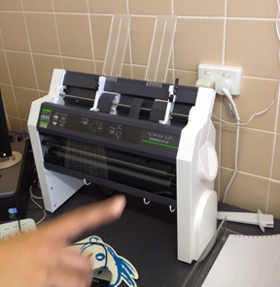
Figure 1: Index Everest D-V4 Embosser

Volume production machines for Braille
Embossing machines with a continuous, tractor feeder are often used for larger scale jobs. The paper’s perforated edges for the tractor feed are then cut manually or mechanically from the resulting Braille pages, and the pages are cut to size.
The image below shows a single-feed machine but quadruple-feed machines are also in use.
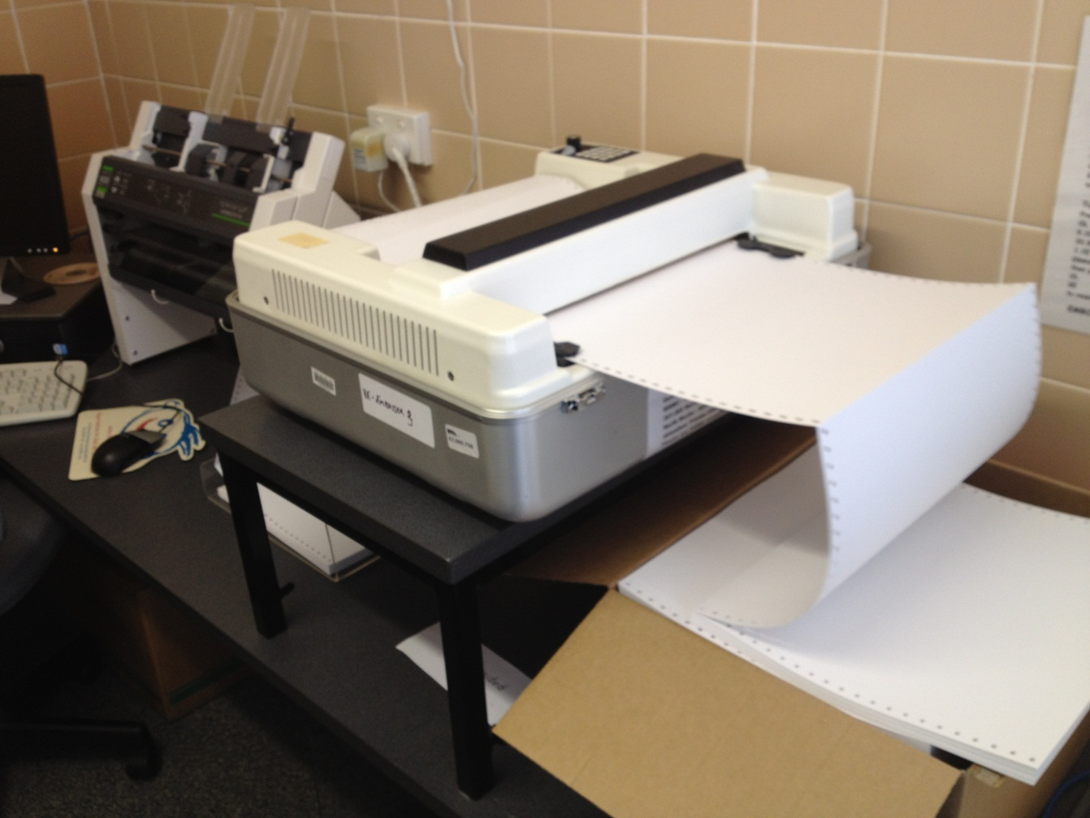
Figure 2: A single, tractor-feed embossing machine

Large print
Large print is text which is bigger than the standard print size and designed using clear print principles.
Large print documents can be designed and printed in the same way as regular print. If reformatting from existing print, this may involve enlarging the text, reformatting or reflowing the text, modifying the artwork and the layout of the publication. For most types of information, large print can be produced effectively using standard word processors and printers.

Large print production for education
Large print production is the most common form of alternative format created for vision impaired students. Large print is provided in Arial font N18 to N48, dependent on a student’s vision. Should a student’s existing sight require a font size larger than N40, they are encouraged to learn Braille within RIDBC schools. Within the public system the maximum size is N48. Sizes N18, N24 and N36 are the most commonly used.
To do a straight photocopy enlargement of a textbook that does not require redesign of the pages, N24 is generally the maximum size that can be reproduced.
Textbooks are often printed on glossy paper which can present a brightness issue for students with low vision, so matte paper is used for large print. Glossy paper also does not scan well for reproduction.
Paper selection may also include coloured paper options, should the student be colourblind. White paper can sometimes create too much glare for a student who is colourblind, or certain colours disappear on a white background, so either buff or green paper is used along with large print according to their preference.
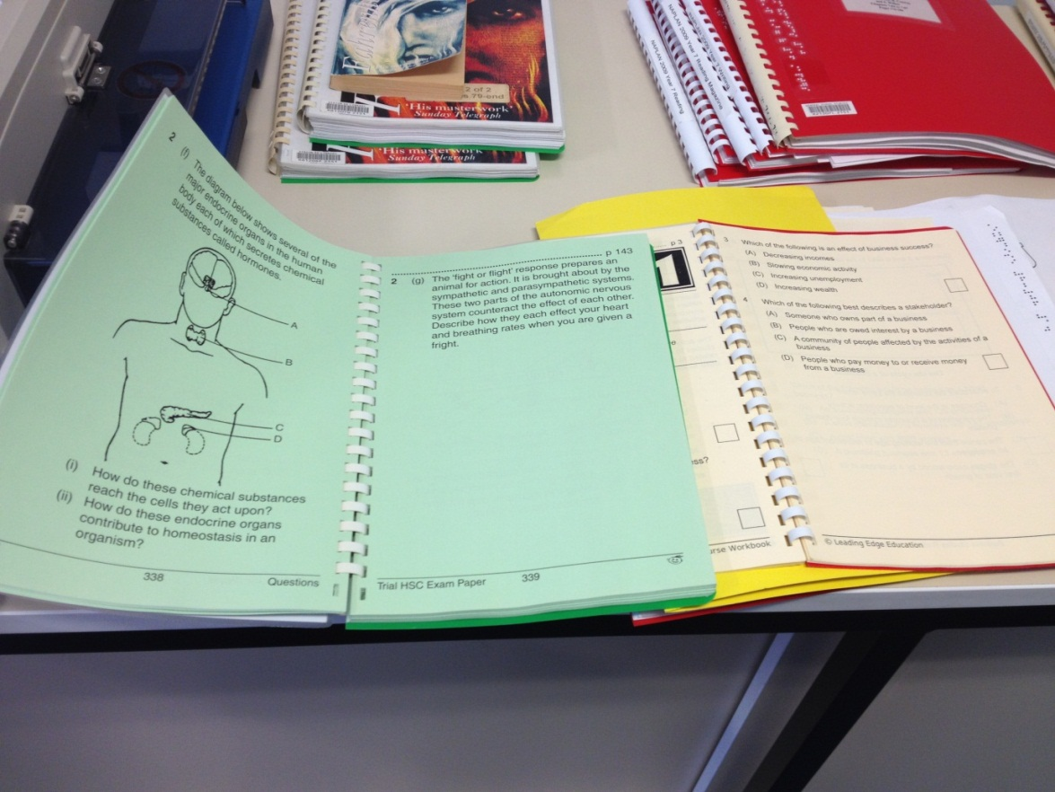
Figure 3: Textbooks showing different colour paper for colourblind students
Large print books may also come in the form of dual-media; that is they are created in large print on the left side of the page and Braille on the right. These are mainly used for young readers who are learning Braille, or will need to learn Braille in the future. A dual-media book allows a sighted-reader to sit with the student and read the text while the student simultaneously feels and learns the Braille on the corresponding page. Dual-media books will also include enlarged pictures where possible. Due to the two types of format required to produce dual-media books, resources in terms of time and cost are much higher than a single media format.
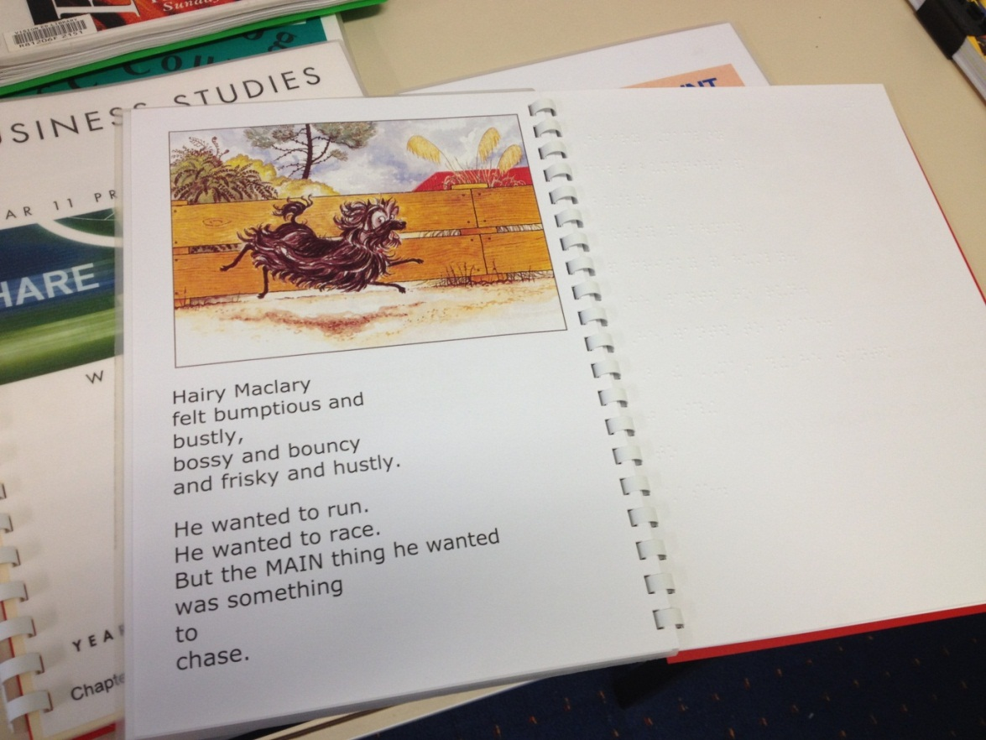
Figure 4: A dual-media book with large print and Braille

Steps in producing large print
Detailed below is the general procedure followed to produce a textbook in large print. Textbooks can be produced a couple of chapters at a time, as required by the student during term or the year. The entire book will be created ultimately. The textbook used in this example was a junior high school geography book.

Scanning
To avoid shadows toward the spine of a textbook the spine will be cut off to create flat pages for every page. The flat, single pages are then scanned through a standard multipurpose device (copier/scanner /printer) using Optical Character Recognition software. RIDBC and the NSW public education system use ABBY Finereader, a highly reputable and inexpensive software similar to Adobe Acrobat Professional. Text, tables and image blocks can be selected and ‘read’. Text is saved as a standard text document.

Text tidying
The text is then tidied to ensure any scanning errors are corrected, as some fonts and hieroglyphics may not be read. Page numbers are inserted – if a page number in a text book is placed at the bottom of the page it will always be moved to the top of the page. Also, as pages in large print may take up more than one A4 page, the same page number may appear twice or more at the top of a large print page to ensure low vision students can locate the appropriate pages as quickly as their classmates. All text tidying is done with reference to style guides, both the Round Table on Information Access for People with Print Disabilities and in RIDBC’s case, their own also. In fact, most organisations have their own methodology/formatting/styles for producing both large print and Braille.

Image scanning
Any images in a textbook are scanned using Photoshop software and scaled up to the appropriate size. Some images include information that is unneeded for educational purposes and simply create clutter, so may be removed. Multiple images on a page may be divided onto numerous pages.

Designing
Desktop publishing software, such as Adobe’s InDesign, is used to put the scanned text and images back into a large print textbook format. Design will also take cognitive processes into account to ensure that the reformatting of text and images is in a rational layout conducive to a student’s ability to relate text and image references. Another formatting example is comprehension exercises such as cloze passages (where a student will fill in missing words in a paragraph of text) requiring larger writing spaces for low vision students. (See Figure 5.)

Proofing
Proofing is then done by either paid staff members or volunteers.

Printing
Printing is done on a standard printer, taking into account a student’s preferred paper colour.

Mailing hard copy
As the resulting textbook is a hard copy it must then be mailed or couriered to a student. In the case of some books, for example Harry Potter and the Chamber of Secrets, as shown below, costs could be considerable. (See Figure 6.)
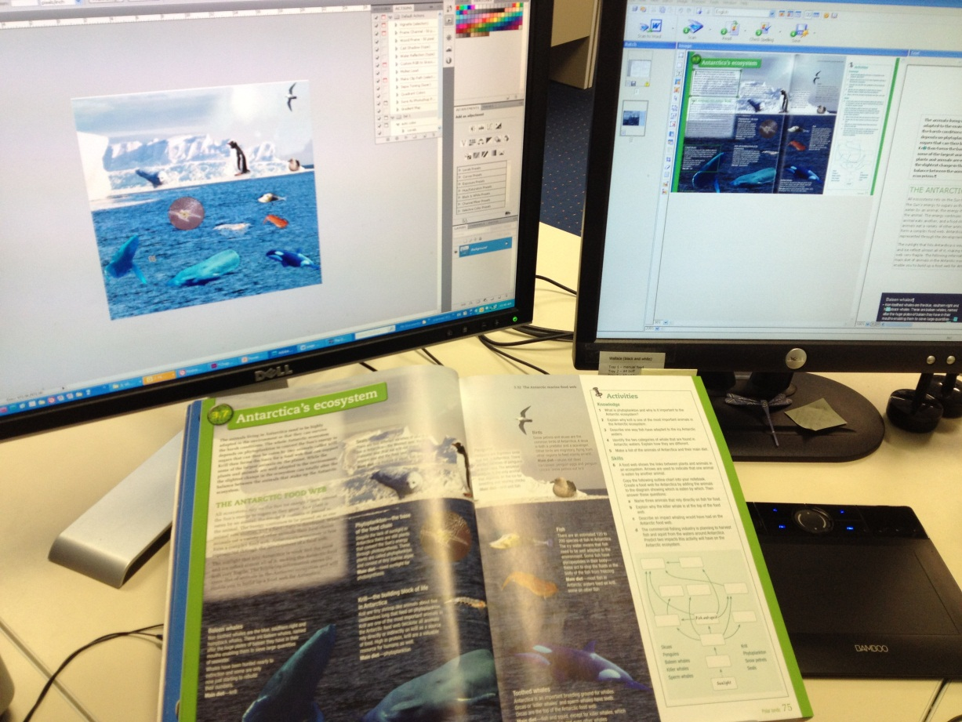
Figure 5: The design process of a large print textbook
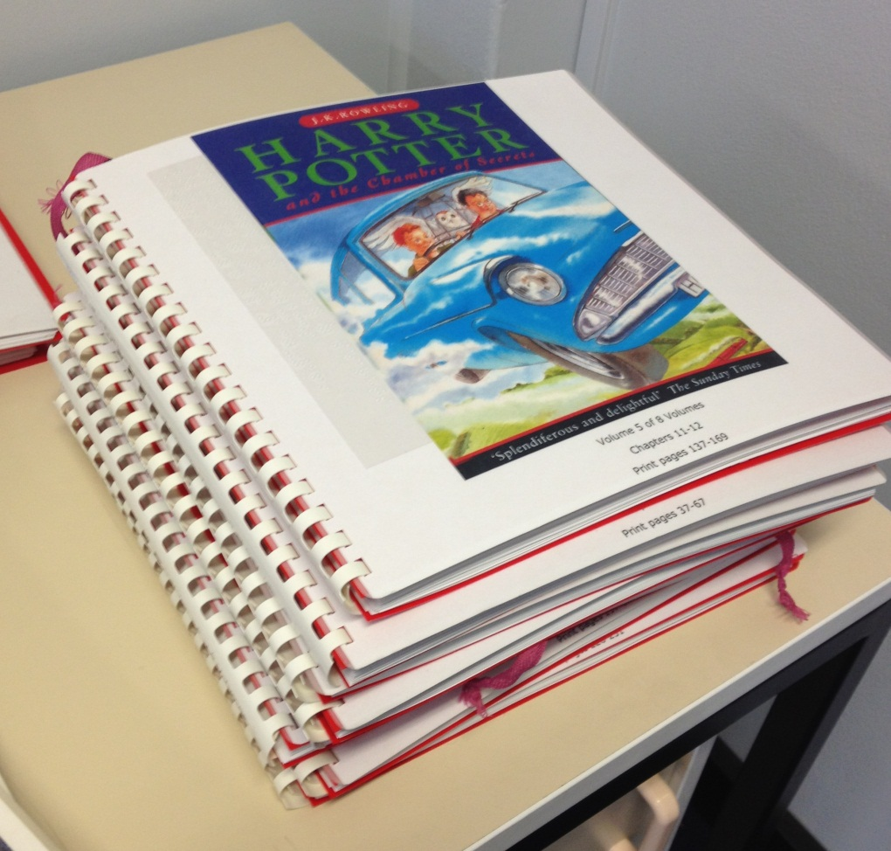
Figure 6: Harry Potter and the Chamber of Secrets in large print

Large print of mainstream books
Beyond the highly specific production of large print textbooks and books for education purposes, as outlined above, there is a library market for mainstream large print books, serviced by a number of publishers in Australia. This publication process is outlined below.
When a book is published the publisher of the normal print edition will usually negotiate large print and audio rights directly with the specialist large print publisher. Sometimes the author holds the rights alone and negotiates the deal themselves. The agreement, regardless of the brokers, will always be completely separate to the normal print one, and done on a book-by-book basis.
There is no set rate on the ratio of normal print to large print; it varies with each book. Even with top authors such as James Patterson, a maximum large print run to sell to libraries will be 900 worldwide, where the normal print run for books going to shops and libraries may be anything between 10,000 and 50,000.
While education large print producers generally follow the Round Table on Information Access for People with Print Disability guidelines, mainstream large print publishers print to their own in-house standards. There are very few publishers of large print in the world and large print is done secondary to normal print, and then only with books considered to be a ‘good read for the majority of the English speaking world’. Large print publishers will be very careful about what they publish, due to the fact that they only sell to libraries and the funding to libraries for large print and audio books is a fraction of what is given for general print and reference and children’s materials.
The costs to the end-user compared to a standard edition are around 2.5 times the normal print copy. This is a net price to libraries and if an individual wants to purchase a title or two they are often sold at the same price. Retail outlets demand discounts, but due to the cost of producing large print, publishers cannot afford to meet those demands, and do not want them to profit from a sale to an individual who is specifically looking for a large print book for themselves or a gift.

Audio format
While English literature texts can often be found in an audio book format, available as a download or on CD, text books are not frequently produced.
Vision Australia (VA), serving Queensland, NSW, ACT and Victoria with outreach services in the Northern Territory and Tasmania, provides audio books for a range of clients, including schools. Audio books beyond English literature may be produced from newspapers, cookbooks, manuals and magazines.
Although synthetic voices are used for straight text reproductions within the general collection (which still need to be checked for inclusions of tricky text such as languages other than English or medical terms) the human voice is still required for education texts which may include diagrammatical information unable to be understood by synthetic voice software. The service is performed voluntarily, with VA recruiting ex-teachers where possible for educational texts.
VA has reported a move to electronic text (e-text) in educational fields, particularly for universities that are producing e-text in-house.
Human narration of a book is naturally a lengthy process, with narration read at roughly 100 words per minute. Add in time for narrator accuracy and other technical changes, and one hour of recorded time may take one-and-a-half to two in real time. Post production and editing is then required. Most small jobs are turned around in 10 working days but educational material, particularly text books, take longer. Synthetic text-to-speech technology is generally quicker to produce, but pre-production of the text file is required for editing and mark-up.
Textbooks are usually split up into volumes or chapters and recorded progressively. Depending on what is being studied by a student, a textbook may not be completely converted to audio, only certain chapters. The volunteer nature of narrators adds to turnaround time as it’s more difficult to schedule studio time compared to a paid narrator.
The demand for textbooks to be produced in an audio format is there but it varies. VA records several hundred hours of educational materials each year. The balance between primary, secondary and tertiary depends on the state or territory and which materials are supplied by government agencies in that state. VA does very little primary school work, some secondary but the majority is tertiary and TAFE.
If a book does have diagrams, illustrations or images that have no informative value, they are omitted from description, but generally figures and tables are scripted by an audio producer and the narration is then recorded. If a diagram is particularly technical, an expert in the field will be sought for advice on the description.
Generally, when a student is enrolled in an educational institution, it will approach VA and an arrangement will be set up for the duration of the student’s years there. There are various ways this contact is made, either through existing contacts, or sales and customer service representatives of VA. Previously, VA had visiting teachers in state schools who fulfilled this role. Students who are clients of VA often recommend or request their services when dealing with their institution’s student/disability support liaison person.
Copyright for educational purposes is covered under Section 135ZQ of the Copyright Act 1968 [http://bit.ly/Y5hfOV], which states the copyright in a published literary or dramatic work is not infringed by the making by, or on behalf of, a body administering an institution assisting persons with a print disability, of a relevant reproduction or a relevant communication of the work, or of a part of the work, if the reproduction or communication is made solely for use in the making by, or on behalf of that body, of a reproduction or communication of the work, or of a part of the work for a person with a print disability. It is only if the book goes into public circulation through Vision Australia’s library that permission from the publisher is required.
All materials recorded in an audio format at Vision Australia are done so using DAISY software, regardless of the end format of DAISY, CD or mp3. If the format required is a CD it will be provided as such, with a DAISY file available if needed in the future simply because of the recording software.
DAISY is considered important for educational material as it allows full navigation for a student to skip straight to chapters, headings, subheadings, figure numbers and pages with ease, and navigate through bibliographies and indexes. Virtual bookmarks can be added and the recording will commence from where the listener last left the recording.
A book produced in synthetic voice (from text) may also be accessed using a software DAISY player to follow the text on-screen in synchronisation with the audio. This may be of no advantage to a totally blind student but may be helpful to those with low-vision using a screen magnifier, and is particularly helpful to people who are dyslexic or have other print disabilities.
DAISY is also a compressed audio format, so instead of a long text book being 10 or more CDs, in most cases an entire DAISY book will fit onto one CD.
When it comes to audio formats, a barrier is the knowledge of service availability within educational centres, and also for students and parents who are not clients of VA. Regardless of whether a student is a client of VA and receives its free Personal Support service or not, material classified as ‘education’ is paid for by the institution. But due to the expense of creating the formats, in some cases an institution will stop production or limit the amount of production, which disadvantages the student. Students receiving VA’s Personal Support service will sometimes get supplementary material done through the service, but there is a limit on the amount of pages that can be narrated. What this means is that students receiving Personal Support services have a better chance of receiving all their required texts narrated compared to non-VA clients, but neither group is assured full service.

Embossing for tactile images
PIAF – Picture In A Flash
PIAF machines require special paper called capsule or swell paper. A graph or image is drawn, printed or photocopied onto the paper which is then passed through the PIAF. Heat causes the lines to swell for users to feel the graph.
A negative of swell paper is its cost, which on average is $3 per sheet.
PIAF machines work with images and Braille with the results displayed in a contrast colour to the paper. Images requiring different patterns to differentiate area can be added, as demonstrated in Figure 1.
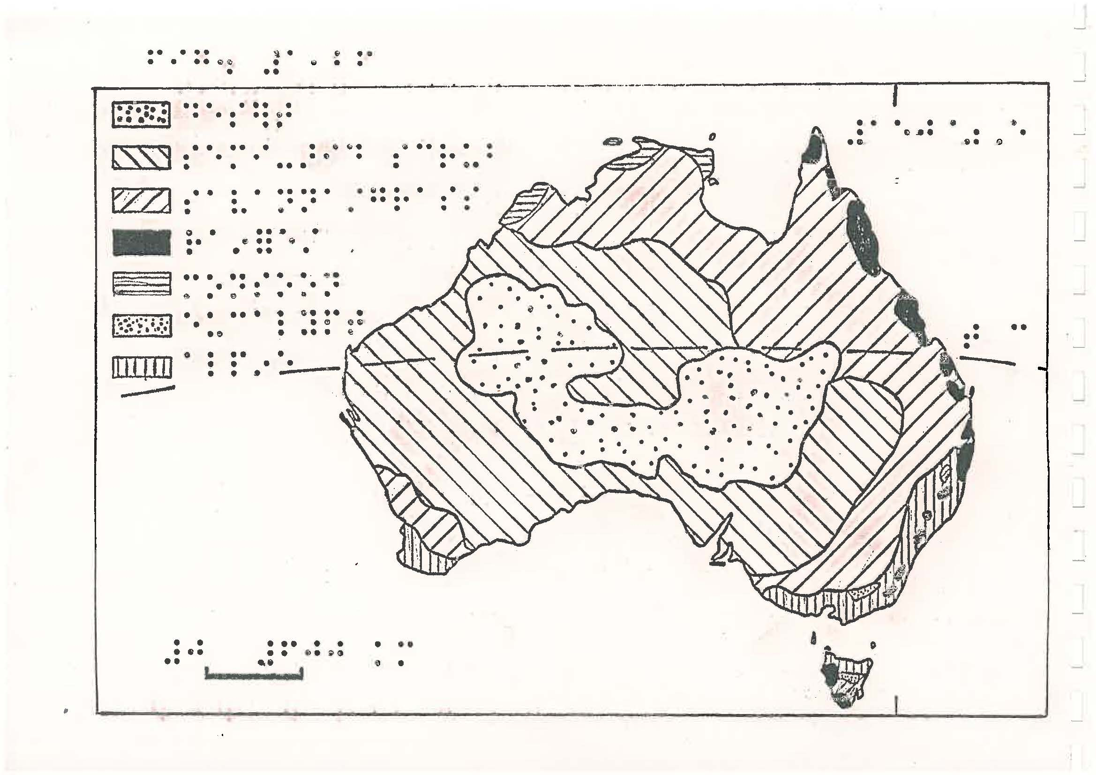
Figure 7: Map of Australia produced on PIAF embosser
Raised diagrams, such as the one above, can sometimes have associated text or images reduced/deleted to ensure essential images and descriptions are included on the same page to relay information. Raised diagrams can also be split into two or more diagrams if required. This could be the case for complex topographical maps or 3D images, both represented below.
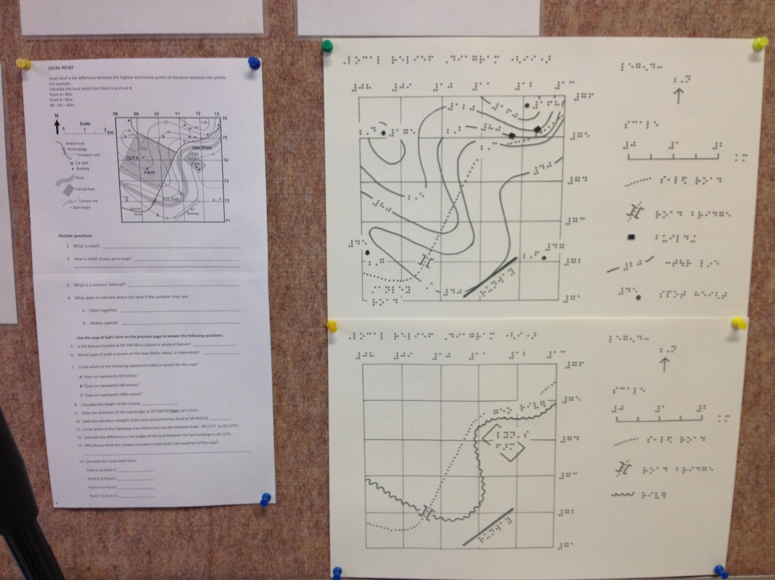
Figure 8: Topographical map, original and Braille version
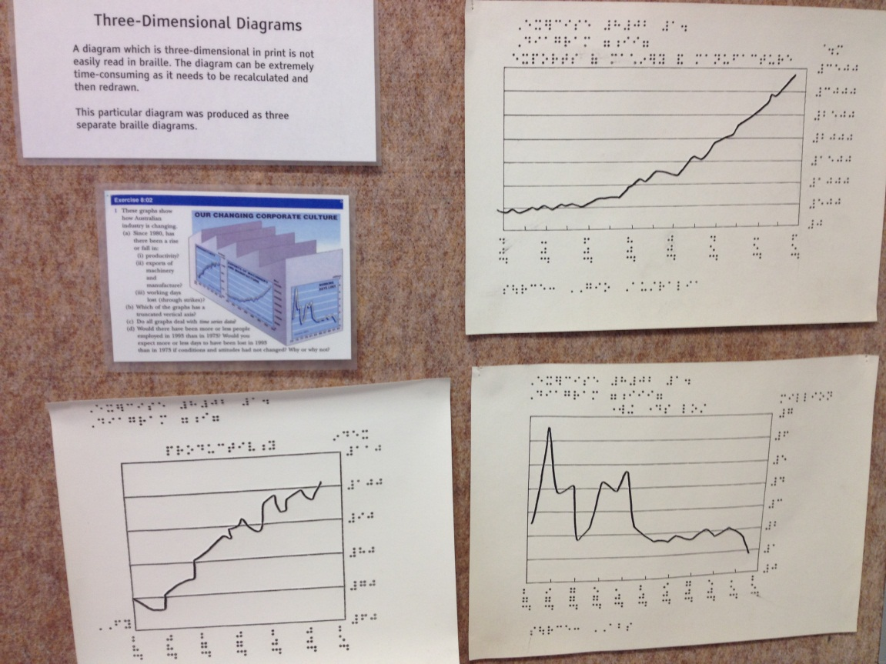
Figure 9: 3D image, original and Braille version
All tactile diagrams are provided back to a student with a transcriber’s note that explains what has been done in the breakdown of the image.
Another consideration in splitting up images is cognitive ability. An image may need to be expanded to a certain size but for a student to still make sense of the image, its explanatory data needs to be placed on the sheet in a relatable position. This may require A3 paper to be used, as shown in the image below, but folded into an A4 book for storage and discretion reasons. (Vision impaired students may not like to handle textbooks or resources that are physically larger than their classmates, as it may draw attention to them as being different.)
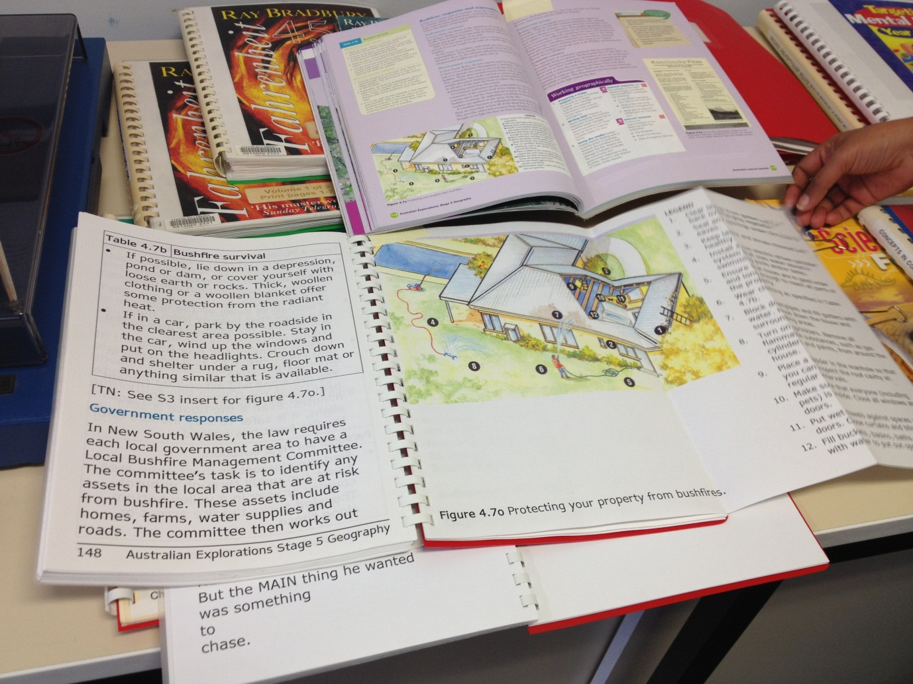
Figure 10: Original book shown with large print edition, included folded A3 diagram
Not every image can be provided in a Braille or large print format, so instead will be described in text for a student. For example, a newspaper clipping of a story around a bushfire, which shows a small photograph of the bushfire in the distance, would not be reproduced in one of the above formats.

Mould paper
Mould paper is often used for the teaching of simple shapes for younger students. Its durable, plastic quality allows for long-term use but it is not used for the printing out of Braille. A vacuum device is used to create the shape around the desired object.
Figure 11: Mould paper showing scissors and looped string

Wikki Stix and other tactile materials
Some teachers use craft products such as Wikki Stix to create tactile resources for students with vision impairment as well as 3D tactile creations for the entire class. Wikki Stix stick to each other and almost any surface and can be re-used. They are made from hand-knitting yarn and enhanced with a special non-toxic, food-grade microcrystalline wax, the kind used in bubble gum and lipsticks. They do not contain gluten, latex, peanut or other nut oils or by-products.
Aside from Wikki Stix, craft resources such as dried pasta and ice cream sticks continue to be used in schools, as they have been for many years, and are considered useful tools for students requiring tactile teaching methods.

Access to the Internet and websites

International standards
The International standard for web accessibility is the Web Content Accessibility Guidelines 2.0, produced by the World Wide Web Consortium (W3C) and designated as ISO/IEC 40500. The document WCAG 2.0 At a Glance [http://www.w3.org/WAI/WCAG20/glance/] provides a basic overview of the 12 guidelines:

Perceivable
- Provide text alternatives for non-text content
- Provide captions and other alternatives for multimedia
- Create content that can be presented in different ways, including by assistive technologies, without losing meaning
- Make it easier for users to see and hear content

Operable
- Make all functionality available from a keyboard
- Give users enough time to read and use content
- Do not use content that causes seizures
- Help users navigate and find content

Understandable
- Make text readable and understandable
- Make content appear and operate in predictable ways
- Help users avoid and correct mistakes
- Robust
- Maximize compatibility with current and future user tools

Government initiatives
In Australia, WCAG 2.0 is a mandatory requirement for all government websites as part of the National Transition Strategy (NTS). The NTS requires that all .gov.au websites must now comply with the minimum Level A standard and meet the Level AA standard by the end of 2014. Further information on the NTS is available from the Department of Finance [http://www.finance.gov.au/publications/wcag-2-implementation/index.html].
Internationally, the United States Rehabilitations Act of 1973, Section 508, also requires government information to be made accessible. Similar accessibility requirements can be found in the European Union, Canada and New Zealand all based around the WCAG 2.0 standard.

Australian initiatives
Some of the projects and work that is being undertaken in Australia to support web accessibility include:
Access iQ – Access iQ [www.accessiq.org] is a social enterprise set up by Media Access Australia to provide resources and information on web accessibility for web professionals and industry. It comprises a fully accessible website (to WCAG 2.0 Level AA) with a mix of free and for fee resources. Access iQ also runs workshops and training programs.
Professional Certificate in Web Accessibility – the PCWA is a joint venture between the University of South Australia and Media Access Australia. It is a 6-week online paid course [http://www.mediaaccess.org.au/learn] aimed at web professionals and provides an extended qualification and in-depth knowledge of practical web accessibility. It runs three times a year.
SociABILITY – a study and report funded by ACCAN (Australian Communications Consumer Action Network) and undertaken by Media Access Australia that is a practical, how-to guide of the accessibility of popular social media [http://www.mediaaccess.org.au/online-media/social-media], including: Twitter, Facebook, YouTube, LinkedIn, Skype and blogs. This is written for predominantly for consumers.
MAA’s NFIS Providers Accessibility Guide – a guide for providers under the National Disability Insurance Scheme that has been funded by the Federal Government and outlines basic web accessibility information, technology and social media. It will be released in second quarter 2013 and has been developed in conjunction with providers of disability services.
COTA WA – a practical, how-to guide for consumers looking at basic web accessibility. It was designed in conjunction with the Council On The Ageing WA and presented as both a train-the-trainer program and written guide (with an audio book version available as well).
Specialist workshops and seminars – a range of suppliers and consultants in Australia provide specialist seminars and workshops around web accessibility issues (although none specialise in school needs). These include: Access iQ, Stamford Interactive and Vision Australia.

The overseas experience

Introduction
A detailed analysis of the range of approaches by different overseas jurisdictions is beyond the scope of this study. However, there are a number of initiatives that have made some progress in access to media and information for blind and vision impaired students. This section focuses more on those as examples of how an issue can be approached and whether they would lead to a similar outcome in Australia. Some of the recommendations for follow-up in this report are built on MAA’s analysis of these programs.

Audio description services

Television
Most of the Western world has an audio description (AD) service on free-to-air television and some limited pay television services. This ranges significantly from levels approaching 30 per cent on some British channels (although the official quotas are much lower) to an hour or two a week on a government-funded public channel. The table below shows some selected countries to illustrate the range.
Country | Current quotas | Notes
Australia | None | 2012 trial on the ABC over 13 weeks
Britain | 10% of programs each 24 hours for broadcasters that have broadcasted for over 10 years. | Many channels audio describe well beyond this.
Canada | Broadcasters must make a commitment in order to have a licence, although no quotas are prescribed. | Outside of legislation, Canada has The Accessible Channel which airs open audio description 24 hours per day.
USA | 4 hours per week for nine major broadcasters, with option by FCC to increase quotas to 7 hours in July 2014. | Obama re-introduced rules under the Twenty-First Century Communications and Video Accessibility Act of 2010.
New Zealand | No formal quotas but the two major channels plus subscription channel SKY provide up to 20 hours of programs per week.
Canada is unusual in that it has a fully open-described channel run by Accessible Media Inc. This is provided and funded via a levy on all cable television subscribers and all providers are required to show the channel. The programming is a mix of older material and some more current programs. The service has also started in-house programming, using blind reporters and covering blind-community events or putting blind perspectives on national issues. The channel is currently applying for a French-language license to provide a similar service for the French-speaking population.
The focus of AD on television is mass-market entertainment programs. Typically the programming is the most popular and limited to non-live programming (due to the inherent difficulties of audio describing live events). Some of those programs include documentaries and series that may form part of school resources, but they do not include programming made predominantly for the education market.
The main impact of this is that blind and vision impaired students do have access and exposure to mainstream audio description services in the home and a degree of awareness of the value of audio description. The provision of audio description is fairly recent and thus the flow-on to other forms of programming, including schools programming, has not yet happened. This contrasts with the experience of captioning, where access is trending to 100% in many countries (including Australia) and a broader range of programming is being made accessible. This also forms impetus for other media to be made accessible.

DVD and cinema
As we reported in Appendix B.7, Australia has the highest level of entertainment DVD access in the world, matched only by the UK. This sits at around a third of new release titles. The level of AD on DVD releases varies significantly from country to country. The highest levels are in the English-speaking world, flowing from the near-100 per cent of AD for Hollywood movie releases. Moving away from English and the levels drop off to a handful of releases and a far less systematic program of access.
Significantly, the genre of accessible DVDs is limited to entertainment. This has some value in that blind and vision impaired students are exposed to AD via watching the latest release DVDs, but there is very little flow-on to the DVDs and other media used in most school subjects. However, this has some value as entertainment releases are used as mainstream school resources and one of the recommendations of this report focuses on this issue.
The most notable exception to this situation is in America where a comprehensive, education-specific service, the Described and Captioned Media Program, is well established and covers the provision of audio description for education programming. This program is described in more detail in section Appendix C.3.
With cinema, the English-speaking world has experienced a recent wave of accessible cinema, with mainstream Hollywood movies including audio description as part of their features. This has been predominantly driven by digital cinema, although the UK introduced cinema AD over 10 years ago through a comprehensive, government-supported program. The main impact of this again is that it provides exposure to an AD service for blind and vision impaired students.
This has been taken one step further by a major school program in the UK, National Schools Film Week, which includes accessible sessions. This program is described in more detail in section Appendix C.4.

Online and downloadable media
Audio description for online and downloadable is currently not available through any media in Australia. Internationally, the BBC’s iPlayer has been in operation since August 2009, offering up to 40 hours per week of audio described video to viewers in the United Kingdom. Programs range from documentaries to soap operas to children’s series, including Eastenders, Dr Who, Junior Vets and Who Do You Think You Are?
A new service, Blindy.TV, is free online service created by blind people. Aiming to make up for the lack of audio description online, it provides five channels of described programming which can be listened to on its built-in media player, or on an external player. There are no border restrictions, making this service available to anyone wherever they are in the world.
The programs available on Blindy.TV come from a variety of sources and include programs recorded off air in locations where audio description is available. There are currently five channels on Blindy.TV: Comedy, Drama, Scifi, Brain and ETC. All programs, which are generally older episodes of TV series, are 30 or 60 minutes long and interspersed with news segments, comedy skits and music.
The entire Blindy.TV service is provided through uncompensated contributions and its creators see it as a stopgap measure, until the mainstream media embrace audio description.

Major initiative – Described and Captioned Media Program (USA)
DCMP is a US initiative run by the Department of Education and the National Association of the Deaf. Its aim is to promote and provide equal access to communication and education to students who are Deaf, hearing impaired, blind, vision impaired or deaf-blind (insert reference to DCMP website). [http://www.dcmp.org/]
DCMP offers a service whereby teachers can borrow captioned or audio described (referred to simply as ‘described in the USA) educational multimedia. Whilst in the early days of the service it mostly consisted of posting DVDs to teachers around the country, nowadays much of DCMP’s content is available for online streaming. The DCMP also houses a range of resources about captioning and audio description on its website, including this webinar on how description can be used in the classroom [http://www.dcmp.org/ai/282/].
Further, the DCMP has been involved in a number of other initiatives aside from providing multimedia content. Some of these initiatives include:
- Description Key
Description Key [http://descriptionkey.org/] was developed as a partnership project for DCMP and the American Foundation for the Blind (AFB). The Description Key website provides a range of clear information about the origination of audio description, guidelines surrounding its creation and use, and more. Description Key has significant potential to raise awareness of audio description within educators as well as media providers.
- Listening is Learning
Listening is Learning [http://www.listeningislearning.com/about.html] was developed as a partnership project for DCMP and the American Council of the Blind (ACB). Listening is Learning (LIL) is an awareness raising initiative designed to promote the benefits of audio described educational media for all students. Teachers, students, parents and media providers get involved in the awareness raising by entering competitions, promoting the value of audio description, and using/creating audio described content.

Major initiative – National Schools Film Week (UK)
National Schools Film Week [http://bit.ly/YBFDHc] is an annual free event which allows teachers and their students to attend screenings of films at their local cinema as part of their curriculum. Over the last few years the festival has made accommodations for students with disabilities, including those with vision loss by programming movies with audio description.
2012 was the festival’s 17th year and hundreds of movies were made accessible through captions and audio description, reflecting the cinema industry’s expansion of these services worldwide. Here are some statistics from 2012:
- More than 530,000 students attended
- Students attended from 4,165 schools.
- 71 per cent of all UK cinemas (530) were a part of the festival.
- 180 movies were shown over numerous screenings.
- Over 250 of these screenings were captioned and/or audio described.
- 15 per cent of students attending the festival were seeing a movie in a cinema for the first time.
The annual event encourages students to engage with and explore the possibilities that film presents through creation and viewing, and to be empowered by film. Screenings were often accompanied by talks from the film-makers, cinema managers, education officers and academics. The festival program is linked with the British school curriculum and includes accessible movies in nearly every participating city.
The festival’s directors believe that the event is a great way of raising awareness among teaching professionals of using film in the curriculum, and talk to teachers about what is required from them as teaching resources. These talks have led to online resources that fit curriculum needs as well as screenings of non-mainstream and foreign language movies.
National Schools Film Week is run by the not-for-profit organisation Film Education, which is funded by British film industry distributors and exhibitors.
In Australia, the Access All Areas Film Festival has been going for five years and over the last three years has toured to schools showing accessible movies. The festival is considerably smaller than National Schools Film Week. In 2012 the Festival toured movies with audio description to three schools in Sydney, and movies with captions for the Deaf and hearing impaired to 20 schools in NSW, WA, Tasmania, South Australia and Queensland.

Glossary
Android – this is an open source operating system primarily designed for touchscreen devices such as smartphones and tablet computers. The most recent version of Android is Jelly Bean 4.2x.
App/application – An application, often abbreviated to ‘app’ is third-party software allowing a Smartphone or tablet user to customise their device to perform specific tasks. Apps are downloaded for free or paid for, and provide a wide range of functions, including but not limited to mapping, entertainment guides, banking, gaming, education and recipes.
Audio books are the recording of texts, read out with a synthetic or human voice. They are most commonly produced for popular mainstream English-language books, and can be bought in stores, loaned from libraries or downloaded from the Internet.
Audio description is the descriptive narration of all the visual elements of a TV program, movie, DVD performance or other media, giving access for the blind or vision impaired. Often referred to as ‘AD’, it may be pre-recorded and delivered as an option for television programs, movies or DVDs, or it may be performed live (e.g. for a theatrical performance).
Blind - Legal blindness in Australia is defined on the Snellen Scale as distance vision acuity of <6/60 in the better eye with correction (i.e. with the use of glasses or contact lenses) or a visual field of less than 10°, or both. This definition was primarily created for purposes of determining welfare and special services access. Total blindness refers to people who are unable to see light.
Braille is a system of reading and writing using raised dots on a page. These dots, in cells of six, represent the letters of the alphabet, numbers and punctuation marks. It is read by moving the fingers from left to right along each line. Usually, people with vision impairment use both hands.
The average reading speed is about 125 words per minute but speeds of up to 200 words per minute are possible. (These rates are comparable with print reading speed.) Most blind people use contracted, or short-hand, Braille.
Braille can be used to read novels, newspapers, textbooks, manuals and everyday material like insurance policies, cookbooks and contracts. It can also be used to pursue hobbies like music, playing cards, Scrabble and other games.
Captions are the transcription of the audio elements of a TV program movie, DVD performance or other media, giving access for the Deaf and hearing impaired. Unlike subtitles, captions include song lyrics, descriptions of sound effects and music, and are often positioned and coloured so as to make it easier for the viewer to identify who is speaking. Captions may be divided into:
- Open captions: captions which are ‘burnt onto’ a video or digital image and will be seen by anyone who looks at it, and;
- Closed captions: captions which a viewer chooses to see (e.g. by accessing captions on TV, or activating the captions on a DVD).
CD-ROM stands for Compact Disc Read-Only Memory, and is a compact disc containing data that is accessible to but not writable by a computer. They are popularly used to distribute software, video games and multimedia applications.
Colour blindness affects approximately 1 in 12 men (8%) and 1 in 200 women in the world. Most colour blind people are able to see things as clearly as other people but they are unable to fully ‘see’ red, green or blue light. The most common form of colour blindness is known as red/green colour blindness and most colour blind people suffer from this. Although known as red/green colour blindness this does not mean sufferers mix up red and green, it means they mix up all colours which have some red or green as part of the whole colour.
DAISY stands for Digital Accessible Information System and is a technical standard for creating audio books. It allows a reader to easily navigate through an audio book by being able to search for chapters, pages and sections.
Data loggers record data over time or in relation to location, either with built-in or external instruments or sensors. These electronic devices are portable and can interface with a personal computer. Data loggers are mainly used for scientific purposes.
Diocese - The Catholic Church in Australia is divided into seven geographical Archdioceses which embrace twenty-one smaller Dioceses. Each Diocese has a Catholic Education Office, responsible for the leadership and efficient operation and management of the Catholic schools within its boundaries. These schools may be also be Catholic independent schools, run by religious orders.
Embossing refers to the creation of an impression of some kind of design, lettering, decoration or pattern onto another surface. Embossing can be done by a variety of machines, manually or via software. The end result is a tactile surface for blind and vision impaired people to learn from. Embossers also produce Braille.
ePub is short for ‘electronic publication’ and allows more flexibility than PDF on a greater number of eReading devices. The main benefit of purchasing ePub formatted eBooks is the ability to rearrange text features such as type, size, line length and character spacing according to reading preferences. The term given to this ability to resize the font is 'reflow', derived from the document adjusting itself according to the page margins when the font size is changed, in the same manner as a word-processing program, adding pages when the font size is increased and removing pages when the font size is decreased.
On many eReaders (except the Sony Reader range), PDF files are similar to a static image and increasing the font size simply zooms in on the image, pushing some of the content off the side of the screen on your device. On your computer the large screen tends to mask this, however it can be tiresome on portable devices. ePub files can circumvent this problem.
eReaders or eBook readers are mobile electronic devices allowing a user to read a digital publication. Some of the most popular eReaders sold in Australia are the Sony Reader, versions of Amazon’s Kindle, iRiver, Kobo eReader Touch and Kobo Glo. eReaders are known for their better readability in sunlit conditions compared to a tablet or laptop screen, and also for their longer battery life. Accessibility though is not a strong point for most eReaders.
HTML stands for Hypertext Markup Language and is known as the publishing language for the World Wide Web.
Interactive whiteboard – An interactive whiteboard (IWB) is an electronic board more common in the classroom as schools progress toward a digital learning environment. They are connected to a computer and a projector by a USB cable, or wirelessly using technology such as Bluetooth. The whiteboard display typically emulates the computer mouse and keyboard and is operated by using a special pen, or finger touch, depending on the model.
iOS is Apple’s operating system, developed specifically for the iPhone, iPad and iPod Touch. The most recent version of iOS is iOS 6.
JAWS is one of the most popular types of screen readers for Windows.
Large print is text which is bigger than the standard print size and designed using clear print principles. Large print documents can be designed and printed in the same way as regular print. If reformatting from existing print, this may involve enlarging the text, reformatting or reflowing the text, modifying the artwork and the layout of the publication. For most types of information, large print can be produced effectively using standard word processors and printers.
Low vision/vision impairment - A person is said to have low vision when their eyesight is limited or impaired and cannot be corrected with conventional glasses or contact lenses. Low vision can affect people of all ages and have an impact on many aspects of a person's life. It may cause problems with recognizing faces, reading the newspaper, dialling the telephone or seeing road signs.
Vision impairment is described as vision impaired in both eyes (visual acuity <6/12).
Magnifier – A magnifier is a low vision aid and its use differs depending on type and focal distance. There are various types of magnifiers:
- Handheld, held away from a page
- Stand magnifiers
- Magnifiers with inbuilt illumination
- Pocket magnifiers
- Video magnifiers – these are electronic and work with an inbuilt camera for more power.
OCR stands for optical character recognition/reader. OCR is the mechanical or electronic conversion of scanned images into machine-encoded text. The scanned image may be handwritten, typewritten or printed text.
PDF stands for Portable Document Format and is a file format that will display documents regardless of the software, hardware or operating system it was created with or is viewed with.
Private schools can be divided into religious (such as Catholic, Lutheran and Christian schools) and non-religious independent schools (such as Montessori and Steiner). Private schools often attract high education fees.
Public school – Public schools, also known as government or state schools, are run by state or territory governments. Covering primary and secondary education, they offer free education to students living within the geographic catchment area. Public schools can also be selective through high entrance requirements from a wider catchment area.
QR codes or ‘Quick Response’ codes are a two-dimensional code that can be ready by Smartphones and dedicated QR-reading devices. They can link the user directly to text, emails, websites or phone numbers amongst other things. QR codes are often used for marketing and advertising of products, brands and services.
Screen readers are a software application that attempts to identify and interpret what is being displayed on a screen. The interpretation is then relayed by text-to-speech or can be output to a Braille device.
Smartphones are more advanced mobile phones, offering users computing connectivity capability. Examples of smartphones are iPhone, Blackberry, Samsung Galaxy and Nokia Symbian.
Tactile refers to something that is perceptible through touch.
Teacher’s aide – Teacher’s aides assist teaching staff in schools by performing non-teaching duties such as care and supervision of children. They assist and participate in learning activities, prepare learning areas and activities, and provide individual assistance to students, particularly those with learning, physical or behavioural difficulties.
Visiting teacher – A visiting teacher is a teacher with specialist knowledge and skills who provides professional development to and assists classroom teachers and school communities with developing teaching and learning adjustments for blind and vision impaired students. A visiting teacher’s time will vary at each school, depending on case load and individual student needs.
WCAG 2.0 – The Web Content Accessibility Guidelines 2.0 cover a wide range of recommendations for making Web content more accessible. The guidelines aim to make content accessible to a wide range of people with disabilities, including blindness and low vision, deafness and hearing loss, learning disabilities, cognitive limitations, limited movement, speech disabilities, photosensitivity and combinations of these.
Windows – Windows refers to Microsoft’s series of graphical user interface operating systems for personal computing. The most recent version is Windows 8.

Acknowledgements
Media Access Australia would like to thank and acknowledge the committed and passionate professionals who contributed information, images and opinions for this study.

Australian Capital Territory
Diane Schwartzkoff, Executive Teacher, Vision Support, ACT Government

New South Wales
Greg Alchin – Department of Education and Communities, NSW
Alan Baynham – Royal Institute for Deaf and Blind Children (RIDBC) Vision Ed
Paul Borkowski - St Edmunds School
Therese Campbell – Catholic Education Office, Wollongong
Stephen Cordwell – Catholic Education Office, Sydney
Michael Corrigan – RIDBC Vision Ed
Louise Cullen – Department of Education and Communities, NSW
Michele Cutrupi – Catholic Education Office, Sydney
Tricia D’Apice – RIDBC Teleschool
Jeanette Davies – Catholic Education Office, Wollongong
Ray Harvey – National Sales & Training Manager, Scientrific
Josie Howse – Department of Education and Communities, NSW
Fiona McInerney – Department of Education and Communities, NSW
Glenda Jacobsen – Royal Far West
Natalie Johnston – Catholic Education Office, Wilcannia-Forbes
Michelle Knight – RIDBC Vision Ed
Sandra Lavender – Director, Large Print, Ulverscroft Publishing
Melissa McCarthy – RIDBC Teleschool
Sonali Marathe – RIDBC Alternative Format Production (AFP) unit
Gita Mathias – Catholic Education Diocese of Parramatta
Glenda Murray – Catholic Education Office, Sydney
Debra Pearce – Vision Australia
Joan Shanahan – Catholic Education Office, Armidale
Sue Silveira – RIDBC Australian Childhood Vision Impairment Register
Michael Ward – Vision Australia
Jill Watson – RIDBC Australian Childhood Vision Impairment Register

Northern Territory
Inge Carter, Vision Services officer, Sanderson Middle School
Liz Christine-Johnson, Vision Services Officer, Sanderson Middle School

Queensland
Melinda Coles, Advisory Visiting Teacher, Education Queensland
Phillipa Enright, Advisory Visiting Teacher, Education Queensland
Thomas McMahon - Statewide Coordinator for Assistive Technology, Education Queensland
Kerry Tait - Head of Special Education Services, Education Queensland

South Australia
Verity Braybrook - Deputy Principal, SA School for Vision Impaired
Sheila Klinger - Principal, SA School for Vision Impaired

Tasmania
Nicole Anthonysz - Vision Impairment Coordinator Catholic Education, Tasmania
Margaret Griffin - State Coordinator, Vision Impairment Service

Victoria
Marion Blaze –Statewide Vision Resource Centre
Judy Connell – Manager, Student Learning Programs, Catholic Education Office, Melbourne
Robyn Gaile – former Chief Executive Officer, Blind Citizens Australia
Deb Lewis – Manager, Statewide Vision Resource Centre
Lee Nagle – Statewide Vision Resource Centre
Lyn Robinson - Statewide Vision Resource Centre
Gary Stinchcombe - Statewide Vision Resource Centre
Emily White – Visiting Teacher, Department of Education and Early Childhood Development

Western Australia
Kaye Garrett – Associate Principal, Vision Education Service
Rebecca Hunt – Visiting Teacher, Vision Education Service
Amanda Lambert - Professional Leader and Visiting Teacher, Vision Education Service
Faye Rowbottam – Visiting Teacher, Vision Education Service

International
New Zealand
Rose Wilkinson – Executive Officer, Association of Blind Citizens of New Zealand Inc.
United Kingdom
Sonali Rai - Media and Culture Development Officer, Royal National Institute of Blind People
United States of America
Bill Stark - Project Director, Described and Captioned Media Program
Dianne Stark - Media Accessibility Administrator, Described and Captioned Media Program
Jason Stark - Project Director, Described and Captioned Media Program

Royal Institute for Deaf and Blind Children
Taken from the Frequently Asked Questions page from Art Beyond Sight. [http://www.artbeyondsight.org/change/aw-faq.shtml#4]
pp 15 ‘E-books for leisure and learning: key findings of a collaboration between NSW Department of Education and Communities (DEC) and Softlink Australia, NSW Curriculum and Learning Innovation Centre’
Source: Vision Australia [http://www.visionaustralia.org.au/info.aspx?page=790 ]
All images courtesy of the Royal Institute for Deaf and Blind Children
From Guidelines for Producing Clear Print, published by the Round Table on Information Access for People with Print Disabilities, 2011
Source: Guidelines for Producing Clear Print, published by the Round Table on Information Access for People with Print Disabilities, 2011
Source: http://www.visionaustralia.org.au/info.aspx?page=583#whatis
Source: http://www.cera.org.au/uploads/CERA_clearinsight_overview.pdf

